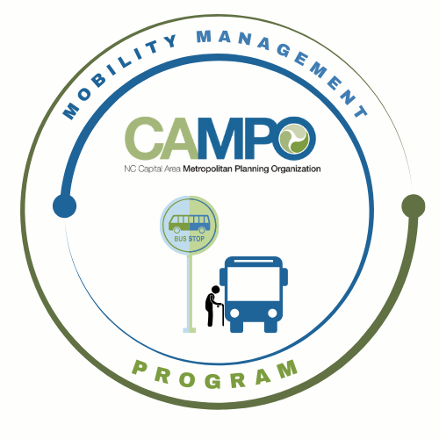
Mobility Coordination Committee (MCC)
Full committee Meeting Thursday, April 16, 2026 - 1:30 pm – 2:30 pm

Coordinated Public Transit - Human Services Transportation Plan

Meeting Agenda

- Welcome/ Introductions/Attendance/Recording – Josh Jensen, MCC Chair

- Agenda Adjustments – Josh Jensen, MCC Chair
No adjustments to the agenda

- October Meeting Minutes – Josh Jensen, MCC Chair
Motion to approve: Sheri Legans
Second: Anita Davis

- Public Comments:
No Public Comments

- MCC Administrative Items – Sarah Keach, Mobility Manager
- Chair opened the floor for nominations.
Shelby nominated Josh for Chair
Anita seconds.
Approved.
Josh nominated Katie as Vice Chair
Shelby seconds.
Approved.
- Calendar – Sarah presents Wednesday and Friday for subcommittee meetings and Thursdays for MCC full meeting. 90 minutes subcommittee meetings; 1 hour for full meetings.
Anita wants to ensure the Wednesday meetings and Wake TAB meetings are not at the same time, which is 9 AM every other month on the first Wednesday. Will hold voting on calendar until Anita can confirm.
Katie states that meeting invites should include the 15 minute buffer between meetings.

- Regional Technology Plan Presentation – Austin Stanion, GoTriangle
Austin gave overview of the Regional Technology Plan. Katie asked if anyone requested projects that would impact demand-response projects yet? GoRaleigh and GoWake operate microtransit. There are paratransit services. Is anyone trying to integrate those services into the technology plan? Austin stated that scope for this plan did not scope a microtransit or demand-response element to this work. Microtransit does relate to other chapters – example: Passenger trip planning app in Chapter 1 could show microtransit zones. Service planning tools like remix could be used for demand-response as well. Transit data standards could apply to demand-response.
- CT Subcommittee January – June 6 month Work Plan Update – Anita Davis, CT Sub-Committee Chair
Completed tasks in Goal 3.
Still in progress – 3.2.4; 1.1.1.
New tasks for rest of FY – 3.2.6, 3.2.7, 3.2.8.
Still discussing use of Public Input w/ WT team and Bonnie.

- ADA Subcommittee January – June 6 month Work Plan Update – Sheri Legans, ADA Sub-Committee Chair Action: Worked on Goals 2.1 and 2.3, and 2.3.1 – ID overlapping ADA/paratransit (completed by Suvir w/ ADA map). Completed 2.1.1 – matrix of characteristics of ADA applications for approval.
Identified suggested coordination opportunities. 2.1.1 – discussion about differences between agencies to better streamline. Will make recommendations from discussion. 2.1.2 – completed matrix but still starting work on operationalizing that analysis.

- Mobility Manager Progress Report – Sarah Keach, Mobility Manager
Sarah met w/ Council of Blind; Council of Developmental Disabilities (NCCDDS) and discussed MMP with them and how to work together. Showed example of info pamphlet geared toward leadership understanding the MMP. Working w/ Kai at ITRE to collect data and use that as info to show progress of MMP. Will have someone from IMD come talk about Concept Funding program for regional coordination.
Chris B suggested putting Sarah in touch with Executive Director at ADA to collaborate on flyer creation.

- CAMPO Updates – Shelby Powell / Sarah Keach
Shelby stated that CAMPO is in process for hiring new Sr Transportation Planner.
5310 program call for projects this year will happen earlier.

- Announcements – Josh Jensen, MCC Chair (5 Minutes)
None

- Adjourn

Next Subcommittee meetings:
- ADA: Wednesday, May 6th, 2026 9:30am-11am
- CT: Wednesday, May 6th, 2026 11am-12:30pm

