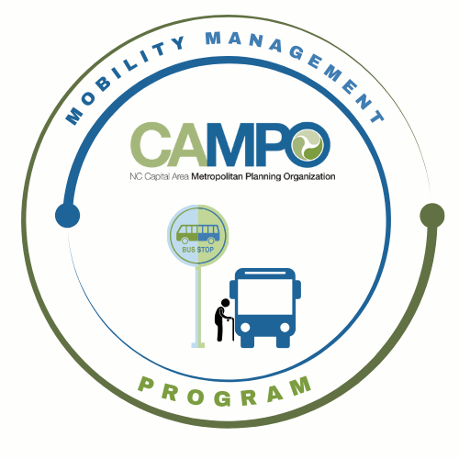
Mobility Coordination Committee (MCC)
Full committee Meeting Thursday, April 16, 2026 - 1:30 pm – 2:30 pm

Coordinated Public Transit - Human Services Transportation Plan

Meeting Agenda

- Welcome/ Introductions/Attendance/Recording – Josh Jensen, MCC Chair

- Agenda Adjustments – Josh Jensen, MCC Chair

- October Meeting Minutes – Josh Jensen, MCC Chair

- Public Comments:

- MCC Administrative Items – Sarah Keach, Mobility Manager
  - MCC Chair and Vice Chair Cabinet Elections
  - Annual calendar

- Regional Technology Plan Presentation – Austin Stanion, GoTriangle
Action: Receive as information

- CT Subcommittee January – June 6 month Work Plan Update – Anita Davis, CT Sub-Committee Chair
Action: Receive as information

- ADA Subcommittee January – June 6 month Work Plan Update – Sheri Legans, ADA Sub-Committee Chair Action: Action: Receive as information

- Mobility Manager Progress Report – Sarah Keach, Mobility Manager
Action: Receive as information

- CAMPO Updates – Shelby Powell / Sarah Keach
Action: Receive as information

- Announcements – Josh Jensen, MCC Chair (5 Minutes)

- Adjourn

Next Subcommittee meetings:
- ADA: Wednesday, May 6th, 2026 9:30am-11am
- CT: Wednesday, May 6th, 2026 11am-12:30pm

