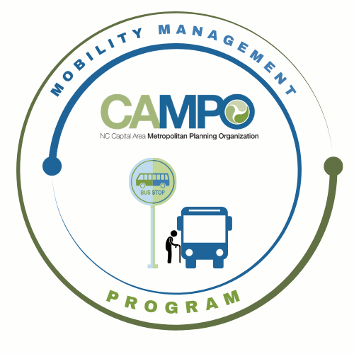
Mobility Coordination Committee (MCC)
CT Sub-committee Meeting Friday, April 10, 2026 – 3:00 pm – 4:30 pm

Coordinated Public Transit - Human Services Transportation Plan

CT Meeting Agenda

- Welcome/ Introductions/Attendance – Anita Davis, CT Sub-Committee Chair
Anita Davis, Natalie Wilson, Paris Butler (GoWake), Sarah Keach, Caleb Allred (CAMPO), Sheri Legans (GoCary), Josh Jensen, Neal Davis (JCATS), Dana Smith (Raleigh), Chris Baucom (ADA), Barry Blevins (HARTS), Chris Clark, Rico Greene (GoTriangle)

- Meeting Minutes– Anita Davis, CT Sub-Committee Chair
Minutes Approved

- Action Item Recap – Anita Davis, CT Sub-Committee Chair
• Update assessment sheets
- Natalie sent updated assessment sheets to agencies to make sure they were updated
• Send shape files
- Received shapefiles from JCATS and GoWake

- Implementation Schedule –Anita Davis, CT Sub-Committee Chair
Anita reviewed the Implementation schedule including the three new goals added:
3.2.6 Identify dedicated funding mechanisms for rural transit agencies.
3.2.7 Expand service hours and days in rural areas as warranted.
3.2.8 Continue to expand public transportation access in eastern Wake County
Anita suggested setting up a meeting with Wake Transit staff to discuss funding opportunities.
Sarah introduced ConCPT funding and discussed regional coordination using the funding as a pilot program. Josh has looked into this before through IMD and stated that it is funding that can only be used once.
Anita asked if any agencies have expanded service hours. GoTriangle, GoRaleigh, and JCATS all stated that they have expanded service. They surveyed riders to capture what people needed out of the service.

- Mobility Coordination/Management Program Updates – Sarah Keach, MM
    - Sarah has been working with Kai at ITRE for data collection
    - Sarah is presenting at NCAMPO in May

- Announcements - Anita Davis, CT Sub-Committee Chair
- Action Items for Next Meeting:
Transit agencies with expanded service to provide more information to Anita about surveying
- Next meetings:

MCC CT Subcommittee Meeting: Wednesday, May 22, 2026 11am – 12:30pm
MCC ADA Subcommittee Meeting: Wednesday, May 22, 2026 9:30am – 11am
MCC Quarterly Meeting: TBD

