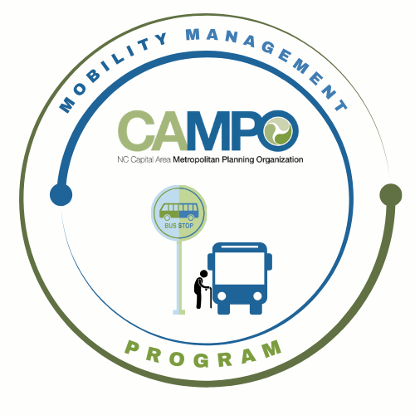
Mobility Coordination Committee (MCC)
ADA Sub-committee Meeting Friday, April 10, 2026 – 1:30 pm – 3:00 pm

Coordinated Public Transit - Human Services Transportation Plan

ADA Meeting Agenda

ADA Meeting Agenda

- Welcome/ Introductions/ Attendance / Recording – Sheri Legans, ADA Sub-Committee Chair
Caleb Allred, Sarah Keach (CAMPO), Chris Baucom (ADA), Katie Schwing (GoApex), Natalie Wilson, Paris Butler (GoWake Access), Rico Greene, Chris Clark (GoTriangle), Sheri Legans (GoCary)
- Meeting Minutes – Katie Schwing Move

- Discussion / Work Session - Sheri Legans, Chair
Please see notes on the document provided with this agenda
- Announcements - Sheri Legans, ADA Sub-Committee Chr
  - Action Items for Next Meeting:
Interactive mapping request
      - Request for ADA required service areas to be mapped
      - Request for other, non-ADA required services to be overlayed as a separated overlay tab
      - Identify regional gaps in service (could be a requested GIS analysis with Tim and Ben)
  - Next meetings:
MCC ADA Subcommittee Meeting: Wednesday, May 6th, 2026 9:30am
MCC CT Subcommittee Meeting: Wednesday, May 6th, 2026 11:00am
1 Fenton Main Street, Suite 201 Cary, NC 27511 | Phone: (984) 542-3602| www.campo-nc.us
Full MCC Meeting: Thursday, April 16, 2026 1:30pm

