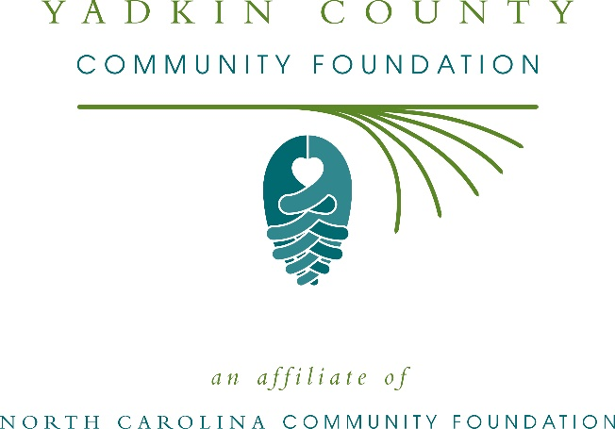
Yadkin County Community Foundation awards more than $9,000 in local grants
The board of advisors of the Yadkin County Community Foundation recently announced $9,390 in local grant awards from its community fund and the Pauline “Polly” Hudspeth Wood & Dr. William L. Wood Sr. Endowment, according to Tom Fagerli, board president.
This year the board granted:
- $634 to Courtney Elementary School for accessible playground equipment for students with autism
- $2,020 to Forbush Elementary for Forbush Guided Reading Book Room
- $2,286 to Yadkin Arts Council for Community Outreach Arts Programming
- $1,000 to Smart Start of Yadkin County, Inc. for Yadkin County State of the Child Conference
- $1,000 to Hospice of Surry Country, Inc. for general operating support
- $1,450 to Fall Creek Elementary for a Library for Learners
- $1,000 to Hands of Hope Medical Clinic for insulin purchase
Fagerli thanked the community for its continued support of the Yadkin County Community Foundation. “We are proud to support these nonprofit programs that are so vital to the community,” he said. “We are grateful to the many generous individuals and organizations that have supported our work to inspire philanthropy across our community.”
For further information, contact NCCF Regional Director Colby Martin at 828-358-0030 or cmartin@nccommunityfoundation.org or visit the NCCF website at nccommunityfoundation.org.
About the Yadkin County Community Foundation
An affiliate of the North Carolina Community Foundation, the Yadkin County Community Foundation is a growing family of philanthropic funds, source of grants for local causes and partner for donors. The YCCF was founded in 1998 and is led by a local volunteer advisory board that helps build community assets through the creation of permanent endowments, makes grants and leverages leadership – all for the benefit of Yadkin County.
The YCCF board advises the Yadkin County Community Foundation, the unrestricted community grantmaking fund, to support local needs. The competitive grants program is held on an annual basis. Advisory board members live and work in Yadkin County, positioning them to strategically leverage resources, meet local needs and access opportunities. In addition to Fagerli, board members include: Dorothy Carter (secretary), Gertrude Adams, Andy Anderson, Mark Diachenko, Wayne Dixon, Lisa Drum, Chris Funk, Todd Martin, Darrell McCormick, Robin Nance, Walter Smith, Barbara Todd and Donna Willingham.
The Yadkin County Community Foundation, through the NC Community Foundation, makes it easy to become a philanthropist, whatever your means or charitable goals. You can open an endowment for your favorite cause at any time – or contribute to an existing fund in any amount. Tax-deductible contributions, made payable to the Yadkin County Community Foundation, can be mailed to the North Carolina Community Foundation, 3737 Glenwood Ave. Suite 460, Raleigh, NC 27612. Contributions can also be made online at nccommunityfoundation.org.
About the North Carolina Community Foundation
The NCCF is the single statewide community foundation serving North Carolina and has administered more than $145 million in grants since its inception in 1988. With more than $270 million in assets, NCCF sustains 1,300 endowments established to provide long-term support of a broad range of community needs, nonprofit organizations institutions and scholarships. The NCCF partners with a network of affiliate foundations to provide local resource allocation and community assistance across the state. An important component of NCCF’s mission is to ensure that rural philanthropy has a voice at local, regional and national levels.
For more information, visit nccommunityfoundation.org.
Cutline for photo
Representatives of local nonprofit grantees at the Yadkin County Community Foundation grant awards reception.
News media contact
Louis Duke, NCCF Senior Communications Specialist
919-256-6922, lduke@nccommunityfoundation.org

