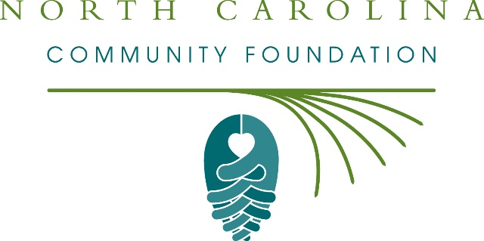
Wayne County nonprofits awarded more than $33,000 in Hurricane Florence recovery grants from the North Carolina Community Foundation Disaster Relief Fund
The board of advisors of the Wayne County Community Foundation was recently awarded $33,750 in recovery grants from the North Carolina Community Foundation Disaster Relief Fund to support the long-term recovery of the local community from Hurricane Florence.
The grant was made from the NCCF Disaster Relief Fund’s initial grantmaking allocations to support long-term recovery and meet unmet needs from Hurricane Florence in Wayne County.
“These grants are critical to the long-term recovery of Wayne County from Hurricane Florence,” said Robert Logan, WCCF board president. “The North Carolina Community Foundation Disaster Relief Fund is a pivotal resource to our local community thanks to the generosity of many donors who gave to help eastern North Carolina.”
NCCF is keenly aware of how deeply Hurricane Florence impacted eastern North Carolina and devastated many communities in our state, according to Jennifer Tolle Whiteside, CEO and president. “The North Carolina Community Foundation has been in these communities for more than 30 years and will continue to be there supporting disaster recovery long after the TV cameras are gone,” she said. “We were grateful to see the outpouring of generosity that supported the NCCF Disaster Relief Fund and are honored to steward these funds to support long-term recovery efforts and meet unmet needs.”
About the Wayne County Community Foundation
The Wayne County Community Foundation is a growing family of philanthropic funds, source of grants for local causes and partners for donors. The WCCF was founded in 1998 and is led by a local volunteer advisory board that helps build community assets through the creation of permanent endowments, makes grants and leverages leadership – all for the benefit of Wayne County.
The WCCF is an affiliate of the North Carolina Community Foundation. In addition to Logan, board members include: Suzi Acree, Harold Brashear, Donna Phillips, Lynn Williams and Edward Wilson.
About the North Carolina Community Foundation
The NCCF is the single statewide community foundation serving North Carolina and has administered more than $145 million in grants since its inception in 1988. With more than $270 million in assets, NCCF sustains 1,300 endowments established to provide long-term support of a broad range of community needs, nonprofit organizations institutions and scholarships. The NCCF partners with a network of affiliate foundations to provide local resource allocation and community assistance across the state. An important component of NCCF’s mission is to ensure that rural philanthropy has a voice at local, regional and national levels.
For more information, visit nccommunityfoundation.org.

News media contact
Louis Duke, NCCF Senior Communications Specialist
919-256-6922, lduke@nccommunityfoundation.org

