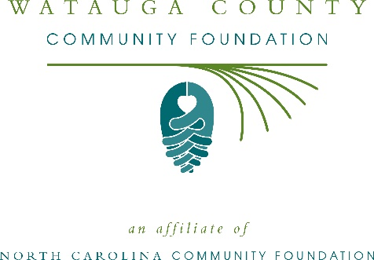
Watauga County Community Foundation awards more than $21,000 in local grants
The board of advisors of the Watauga County Community Foundation recently announced $21,275 in local grant awards from its community grantmaking fund and the Armfield and Rachel Rivers Coffey Memorial Fund, according to Stephen Poulos, board president.
This year the board granted:
- $1,250 to Spirit Ride, Inc. for scholarship funding
- $2,500 to Children’s Council of Watauga County, Inc. for the Family Literacy Program
- $3,000 to the Back 2 School Festival for the event
- $1,500 to Blue Ridge Women in Agriculture for their effort to increase equitable access to healthy local food
- $500 to Appalachian Regional Library for their 2019 Good Neighbor Project: Stories of Hope and Recovery
- $1,500 to the Hospitality House of the Boone area for the Hospitality House Garden Revitalization Project
- $1,500 to Mountain Alliance for the School’s Out Afterschool Academic Support Program
- $1,000 to the Children’s Playhouse for program support
- $1,025 to the Watauga County Habitat for Humanity for Financial Literacy for Homeowners
- $1,000 to Foscoe Grandfather Community Center for an upgraded playground area
- $500 to the Watauga County Arts Council for a space for the ARTS at ArtSpace
- $6,000 to the Hunger and Health Coalition for a fresh market and free pharmacy
Poulos thanked the community for its continued support of the Watauga County Community Foundation. “We are proud to support these nonprofit programs that are so vital to the community,” he said. “We are grateful to the many generous individuals and organizations that have supported our work to inspire philanthropy across our community.”
For further information, contact NCCF Regional Director Colby Martin at 828-358-0030 or cmartin@nccommunityfoundation.org or visit the NCCF website at nccommunityfoundation.org.

About the Watauga County Community Foundation
An affiliate of the North Carolina Community Foundation, the Watauga County Community Foundation is a growing family of philanthropic funds, source of grants for local causes and partner for donors. The WCCF was founded in 1991 and is led by a local volunteer advisory board that helps build community assets through the creation of permanent endowments, makes grants and leverages leadership – all for the benefit of Watauga County.
The WCCF board advises the Watauga County Community Foundation, the unrestricted community grantmaking fund, to support local needs. The competitive grants program is held on an annual basis. Advisory board members live and work in Watauga County, positioning them to strategically leverage resources, meet local needs and access opportunities. In addition to Poulos, board members include: Brian Crutchfield (vice president/grants chair), Ryan Postlethwait (secretary), Bettie Bond, David Jackson, Brad Moretz, Gary Moss, Jane Rogers and Don Saunders.
The Watauga County Community Foundation, through the NC Community Foundation, makes it easy to become a philanthropist, whatever your means or charitable goals. You can open an endowment for your favorite cause at any time – or contribute to an existing fund in any amount. Tax-deductible contributions, made payable to the Watauga County Community Foundation, can be mailed to the North Carolina Community Foundation, 3737 Glenwood Ave. Suite 460, Raleigh, NC 27612. Contributions can also be made online at nccommunityfoundation.org.
About the North Carolina Community Foundation
The NCCF is the single statewide community foundation serving North Carolina and has administered more than $145 million in grants since its inception in 1988. With more than $270 million in assets, NCCF sustains 1,300 endowments established to provide long-term support of a broad range of community needs, nonprofit organizations institutions and scholarships. The NCCF partners with a network of affiliate foundations to provide local resource allocation and community assistance across the state. An important component of NCCF’s mission is to ensure that rural philanthropy has a voice at local, regional and national levels.
For more information, visit nccommunityfoundation.org.
News media contact
Louis Duke, NCCF Senior Communications Specialist
919-256-6922, lduke@nccommunityfoundation.org

