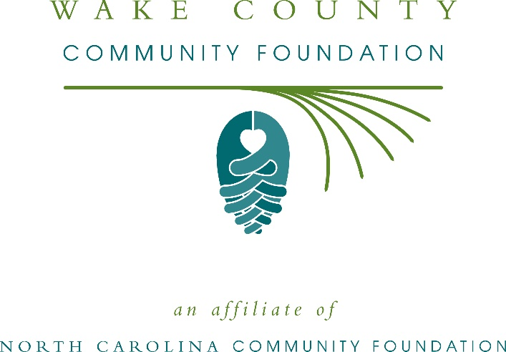
Wake County Community Foundation awards more than $11,000 in local grants
The board of advisors of the Wake County Community Foundation recently announced $11,350 in local grant awards from its community grantmaking fund and the Friends of BOMA Charitable Endowment, according to Katie Weeks, board president.
This year the board granted:
- $1,000 to The Hope Center at Pullen for Lighting a Path to a Safe and Stable Adulthood for Former Foster Youth
- $1,500 to Ship Outreach and Community Center for general operating support
- $1,500 to Community Helpers Service Center, Inc. for a food pantry
- $1,500 to You Call This Yoga for yoga classes for veterans in Wake County
- $1,500 to the Center for Volunteer Caregiving for an in-home connections program
- $1,000 to 100 Black Men Triangle East for general operating support
- $1,500 to The Gifted Arts, Inc. for Gifted Academy
- $850 to Helping Horse, Inc. for therapeutic horseback riding lessons for individuals with disabilities
- $1,000 to NAMI Wake County for support and education for family members of those living with a mental illness
Weeks thanked the community for its continued support of the Wake County Community Foundation. “We are proud to support these nonprofit programs that are so vital to the community,” she said. “We are grateful to the many generous individuals and organizations that have supported our work to inspire philanthropy across our community.”
For further information, contact NCCF Grants Program Manager Christopher Fipps at 919-256-6923 or cfipps@nccommunityfoundation.org or visit the NCCF website at nccommunityfoundation.org.

About the Wake County Community Foundation
An affiliate of the North Carolina Community Foundation, the Wake County Community Foundation is a growing family of philanthropic funds, source of grants for local causes and partner for donors. The WCCF was founded in 1991 and is led by a local volunteer advisory board that helps build community assets through the creation of permanent endowments, makes grants and leverages leadership – all for the benefit of Wake County.
The WCCF board advises the Wake County Community Foundation, the unrestricted community grantmaking fund, to support local needs. The competitive grants program is held on an annual basis. Advisory board members live and work in Wake County, positioning them to strategically leverage resources, meet local needs and access opportunities. In addition to Weeks, board members include: Tim Poirier (treasurer), La Nica Allison (secretary), Randy Cagan, Marty Clayton, Juan Carlos Erickson, Cameron Flowers, Sarah Gaskill, Ellen Gorham, Michelle Keaton-Barrow, Rebecca Leggett, Ruth Peebles, Peter Roche and Jerry Sayre.
The Wake County Community Foundation, through the NC Community Foundation, makes it easy to become a philanthropist, whatever your means or charitable goals. You can open an endowment for your favorite cause at any time – or contribute to an existing fund in any amount. Tax-deductible contributions, made payable to the Wake County Community Foundation, can be mailed to the North Carolina Community Foundation, 3737 Glenwood Ave. Suite 460, Raleigh, NC 27612. Contributions can also be made online at nccommunityfoundation.org.
About the North Carolina Community Foundation
The NCCF is the single statewide community foundation serving North Carolina and has administered more than $145 million in grants since its inception in 1988. With more than $270 million in assets, NCCF sustains 1,300 endowments established to provide long-term support of a broad range of community needs, nonprofit organizations institutions and scholarships. The NCCF partners with a network of affiliate foundations to provide local resource allocation and community assistance across the state. An important component of NCCF’s mission is to ensure that rural philanthropy has a voice at local, regional and national levels.
For more information, visit nccommunityfoundation.org.
News media contact
Louis Duke, NCCF Senior Communications Specialist
919-256-6922, lduke@nccommunityfoundation.org

