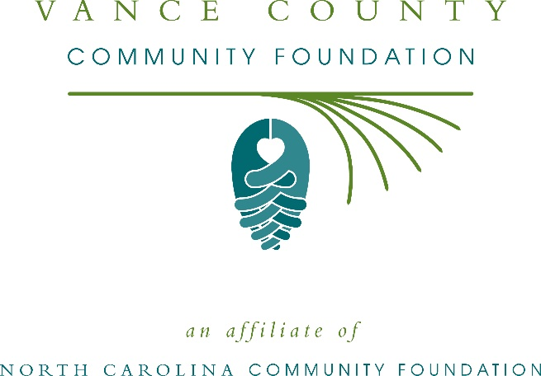
Vance County Community Foundation awards more than $7,000 in local grants
The board of advisors of the Vance County Community Foundation recently announced $7,470 in local grant awards from its community grantmaking fund, the Edna Freeman Murray and Ralph Murray Charitable Fund, and Volunteers of Maria Parham Medical Center Health Awareness Endowment, according to Wendy Meyer-Goodwin, board president.
This year the board granted:
- $1,000 to Prevent Blindness North Carolina for Star Pupils Vance County
- $1,470 to Franklin Granville Vance Smart Start, Inc. for their Adolescent Parenting Program
- $1,500 to Henderson-Vance Downtown Development Commission for the Henderson Downtown Pavilion
- $1,500 to Vance County FIRST Robotics for Vance County FIRST Robotics team, 4291 Astrobots
- $2,000 to Life Line Outreach for increasing t he laundry facilities available for single women
Meyer-Goodwin thanked the community for its continued support of the Vance County Community Foundation. “We are proud to support these nonprofit programs that are so vital to the community,” she said. “We are grateful to the many generous individuals and organizations that have supported our work to inspire philanthropy across our community.”
For further information, contact NCCF Grants Program Manager Christopher Fipps at 919-256-6923 or cfipps@nccommunityfoundation.org or visit the NCCF website at nccommunityfoundation.org.
About the Vance County Community Foundation
An affiliate of the North Carolina Community Foundation, the Vance County Community Foundation is a growing family of philanthropic funds, source of grants for local causes and partner for donors. The VCCF was founded in 1997 and is led by a local volunteer advisory board that helps build community assets through the creation of permanent endowments, makes grants and leverages leadership – all for the benefit of Vance County.
The VCCF board advises the Vance County Community Foundation, the unrestricted community grantmaking fund, to support local needs. The competitive grants program is held on an annual basis. Advisory board members live and work in Vance County, positioning them to strategically leverage resources, meet local needs and access opportunities. In addition to Meyer-Goodwin, board members include: Anthony Adams (secretary), Sarah Baskerville, Fagan Goodwin, Terri Hedrick, Amy Russell and Sara Wester.
The Vance County Community Foundation, through the NC Community Foundation, makes it easy to become a philanthropist, whatever your means or charitable goals. You can open an endowment for your favorite cause at any time – or contribute to an existing fund in any amount. Tax-deductible contributions, made payable to the Vance County Community Foundation, can be mailed to the North Carolina Community Foundation, 3737 Glenwood Ave. Suite 460, Raleigh, NC 27612. Contributions can also be made online at nccommunityfoundation.org.
About the North Carolina Community Foundation
The NCCF is the single statewide community foundation serving North Carolina and has administered more than $145 million in grants since its inception in 1988. With more than $270 million in assets, NCCF sustains 1,300 endowments established to provide long-term support of a broad range of community needs, nonprofit organizations institutions and scholarships. The NCCF partners with a network of affiliate foundations to provide local resource allocation and community assistance across the state. An important component of NCCF’s mission is to ensure that rural philanthropy has a voice at local, regional and national levels.
For more information, visit nccommunityfoundation.org.
News media contact
Louis Duke, NCCF Senior Communications Specialist
919-256-6922, lduke@nccommunityfoundation.org

