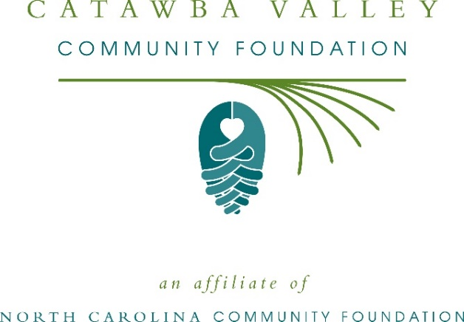
UNC School of the Arts for Catawba County Fund awards more than $14,000 in local grants
The board of advisors of the University of North Carolina School of the Arts for Catawba County Fund announces $14,310 in local grant awards, according to Sally Fanjoy, committee chair.
This year’s recipients include:
- $8,000 to UNCSA Foundation for scholarships to the University of North Carolina School of the Arts for students from Catawba County
- $5,710 to the Western Piedmont Symphony to support fee assistance for engagement of UNCSA students in music programs
- $600 to the United Arts Council of Catawba County to support UNCSA judges and for the Edna Bost Barringer Young Artists Award
Fanjoy thanked the community for its support of the UNC School of the Arts for Catawba County Fund. “These grants are important to our community and our quality of life,” she said. “Critical programs would not be possible without the generosity of many individuals and organizations that have supported the fund.”
About the UNC School of the Arts for Catawba Fund
The UNC School of the Arts for Catawba County is a fund of the Catawba Valley Community Foundation. The fund was created to offer scholarships and support to Catawba County students attending the University of North Carolina School of the Arts. In addition to Fanjoy, board members include: Margie Owsley, Phil Barringer, John Coffey, Kim George, Michelle Morgan and Connie Kincaid.
Tax-deductible contributions, made payable to the UNC School of the Arts for Catawba County Fund of the Catawba Valley Community Foundation can be mailed to the North Carolina Community Foundation, 3737 Glenwood Ave. Suite 460, Raleigh, N 27612. Contributions can also be made online at nccommunityfoundation.org.
For further information, contact NCCF Regional Director Colby Martin at 828-358-0030 or cmartin@nccommunityfoundation.org or visit the NCCF website at nccommunityfoundation.org.
About the Catawba Valley Community Foundation
The Catawba Valley Community Foundation is a growing family of philanthropic funds, source of grants for local causes and partners for donors. The CVCF was founded in 1997 and is led by a local volunteer advisory board that helps build community assets through the creation of permanent endowments, makes grants and leverages leadership – all for the benefit of Caldwell, Alexander and Catawba counties.
The CVCF board advises the Catawba Valley Community Foundation Fund, the unrestricted community grantmaking fund, to support local needs. In addition to Coley, board members include: Michelle Kirby (vice president), Lilly Skok Bunch (secretary), Suzan Anderson, Alex Bernhardt, Becky Gibbons, Gary Herman, Mandy Pitts-Hildebrand, Brice Melton, Jamie Treadaway, Beth Rogers and John Teeter.
The Catawba Valley Community Foundation, through the NC Community Foundation, makes it easy to become a philanthropist, whatever your means or charitable goals. You can open an endowment for your favorite cause at any time – or contribute to an existing fund in any amount. Tax-deductible contributions, made payable to the Catawba Valley Community Foundation, can be mailed to the North Carolina Community Foundation, 3737 Glenwood Ave. Suite 460, Raleigh, NC 27612. Contributions can also be made online at nccommunityfoundation.org.

About the North Carolina Community Foundation
The NCCF is the single statewide community foundation serving North Carolina and has administered more than $145 million in grants since its inception in 1988. With more than $270 million in assets, NCCF sustains 1,300 endowments established to provide long-term support of a broad range of community needs, nonprofit organizations institutions and scholarships. The NCCF partners with a network of affiliate foundations to provide local resource allocation and community assistance across the state. An important component of NCCF’s mission is to ensure that rural philanthropy has a voice at local, regional and national levels.
For more information, visit nccommunityfoundation.org.
Cutline for photo
Board members of the UNC School of the Arts for Catawba County Fund pictured with their grant check.

News media contact
Louis Duke, NCCF Senior Communications Specialist
919-256-6922, lduke@nccommunityfoundation.org

