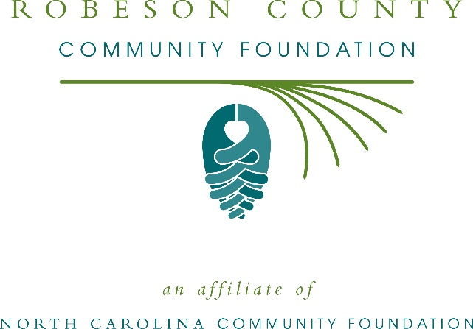
Robeson County Community Foundation awards more than $11,000 in local grants
The board of advisors of the Robeson County Community Foundation recently announced $11,740 in local grant awards from its community grantmaking fund, according to Kenny Biggs, board president.
This year the board granted:
- $1,250 to UNC Pembroke Entrepreneurship/Incubator-Thomas Center for Entrepreneurship for young entrepreneurs
- $1,000 to Girl Scouts – North Carolina Coastal Pines for Robeson County Girl Scout Leadership Experience
- $1,000 to Robeson County Partnership for Children, Inc. for Exploration Station Summer STEAM Camp
- $1,290 to Robeson County Humane Society to purchase a commercial washer
- $1,000 to Pembroke Housing Authority for Healthy Aging in Creative Arts
- $1,000 to Ronald McDonald House of Chapel Hill for Robeson County Cares Fund
- $2,000 to the University of North Carolina at Pembroke-Office for Regional Initiatives for the 2020 Women’s Empowerment Summit
- $1,200 to Arrested Potential, Inc. for general program support
- $1,000 to CIS of Robeson County for BakPak Pals
- $1,000 to Red Springs Art Council for Third Saturday at the Farmers Market
Biggs thanked the community for its continued support of the Robeson County Community Foundation. “We are proud to support these nonprofit programs that are so vital to the community,” he said. “We are grateful to the many generous individuals and organizations that have supported our work to inspire philanthropy across our community.”
For further information, contact NCCF Regional Director Anne Sorhagen at 910-202-6727 or asorhagen@nccommunityfoundation.org or visit the NCCF website at nccommunityfoundation.org.

About the Robeson County Community Foundation
An affiliate of the North Carolina Community Foundation, Robeson County Community Foundation is a growing family of philanthropic funds, source of grants for local causes and partner for donors. The RCCF was founded in 2005 and is led by a local volunteer advisory board that helps build community assets through the creation of permanent endowments, makes grants and leverages leadership – all for the benefit of Robeson County.
The RCCF board advises the Robeson County Community Foundation, the unrestricted community grantmaking fund, to support local needs. The competitive grants program is held on an annual basis. Advisory board members live and work in Robeson County, positioning them to strategically leverage resources, meet local needs and access opportunities. In addition to Biggs, board members include: Ken Windley (vice president), Marcus Bryant (treasurer), Sylvia Pate (secretary), Alfred Bryant, John Carter, Sara Hayes, Bruce Huggins, Abraham Marshall, Bryan Maynor, Mike McGehee, Sandra Oliver, Viv Wayne and Margaret Morley.
The Robeson County Community Foundation, through the NC Community Foundation, makes it easy to become a philanthropist, whatever your means or charitable goals. You can open an endowment for your favorite cause at any time – or contribute to an existing fund in any amount. Tax-deductible contributions, made payable to the Robeson County Community Foundation, can be mailed to the North Carolina Community Foundation, 3737 Glenwood Ave. Suite 460, Raleigh, NC 27612. Contributions can also be made online at nccommunityfoundation.org.
About the North Carolina Community Foundation
The NCCF is the single statewide community foundation serving North Carolina and has administered more than $145 million in grants since its inception in 1988. With more than $270 million in assets, NCCF sustains 1,300 endowments established to provide long-term support of a broad range of community needs, nonprofit organizations institutions and scholarships. The NCCF partners with a network of affiliate foundations to provide local resource allocation and community assistance across the state. An important component of NCCF’s mission is to ensure that rural philanthropy has a voice at local, regional and national levels.
For more information, visit nccommunityfoundation.org.
News media contact
Louis Duke, NCCF Senior Communications Specialist
919-256-6922, lduke@nccommunityfoundation.org

