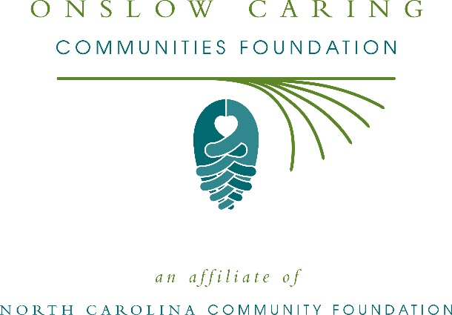
Onslow Caring Communities Foundation awards more than $56,000 in local grants
The board of advisors of Onslow Caring Communities Foundation recently announced $56,060 in local grant awards from its community grantmaking fund, the Onslow County Youth Fund, and the Dallas Fred Allen Endowment according to Debbi Ray Rouse, board president.
This year the board granted:
- $3,000 to Prevent Blindness North Carolina for Star Pupils Onslow County
- $1,050 to NC United Methodist Camp & Retreat Ministries, Inc. for establishing a need-based scholarship for environmental education and teambuilding at Camp Don Lee
- $3,000 to the city of Jacksonville for City of Jacksonville HARMONY Youth Grants Board Philanthropy Initiative
- $3,000 to Sturgeon City of Jacksonville NC for Science for Teens
- $3,000 to Brigade Boys & Girls Club of Wilmington for Brigade Boys & Girls Club Onslow County Youth Development Programming
- $1,030 to the Children’s Museum of Jacksonville for Professional Development – Association of the Children’s Museum Interactivity 2020 Conference
- $2,000 to Ronald McDonald House of Chapel Hill for Onslow County Cares Fund
- $2,000 to Ronald McDonald House of Eastern NC for general operating expenses for Funding a Family
- $1,000 to Mediation Center of Eastern Carolina-Duplin for Onslow Teen Court Outreach
- $3,000 to Eastern Carolina Young Men’s Christian Association for the 2019 New River YMCA Needs Based Day Camp Scholarships
- $2,000 to North Carolina Symphony Society for Music Education Concert for Onslow County Students
- $3,000 to the University of North Carolina Wilmington for Nonprofit Capacity Building- Onslow County
- $5,000 to Jaded Paws for Jaded Paws Rescue
- $830 to the North Carolina Coastal Land Trust for the Pollinator Garden at Everett Creek Preserve
- $20,000 to Possumwood Acres Wildlife Sanctuary for the Come Find Your CENTER (Caring, Eco-Therapy, Nature, Tranquility, Environment, Raptors) Program
- $3,150 to the University of North Carolina at Wilmington for QENO Npo NPO Capacity: Possumwood Acres
Rouse thanked the community for its continued support of Onslow Caring Communities Foundation. “We are proud to support these nonprofit programs that are so vital to the community,” she said. “We are grateful to the many generous individuals and organizations that have supported our work to inspire philanthropy across our community.”
For further information, contact NCCF Regional Director Anne Sorhagen at 910-202-6727 or asorhagen@nccommunityfoundation.org or visit the NCCF website at nccommunityfoundation.org.
About the Onslow Caring Communities Foundation
An affiliate of the North Carolina Community Foundation, the Onslow Caring Communities Foundation is a growing family of philanthropic funds, source of grants for local causes and partner for donors. OCCF was founded in 2000 and is led by a local volunteer advisory board that helps build community assets through the creation of permanent endowments, makes grants and leverages leadership – all for the benefit of Onslow County.
The OCCF board advises Onslow Caring Communities Foundation, the unrestricted community grantmaking fund, to support local needs. The competitive grants program is held on an annual basis. Advisory board members live and work in Onslow County, positioning them to strategically leverage resources, meet local needs and access opportunities. In addition to Rouse, board members include: Robert M. Sheegog, Jr. (vice president), Anne Marie Raymond (treasurer), Pete Burgess, Alycia Kellum, Korene Marsh, Rodney Martin, Robert Kevin McConnell, Julee Sewell, Susan Stevenson, Steve Wangerin, Joe Jarman and Gregory Williams.
Onslow Caring Communities Foundation, through the NC Community Foundation, makes it easy to become a philanthropist, whatever your means or charitable goals. You can open an endowment for your favorite cause at any time – or contribute to an existing fund in any amount. Tax-deductible contributions, made payable to Onslow Caring Communities Foundation, can be mailed to the North Carolina Community Foundation, 3737 Glenwood Ave. Suite 460, Raleigh, NC 27612. Contributions can also be made online at nccommunityfoundation.org.
About the North Carolina Community Foundation
The NCCF is the single statewide community foundation serving North Carolina and has administered more than $145 million in grants since its inception in 1988. With more than $270 million in assets, NCCF sustains 1,300 endowments established to provide long-term support of a broad range of community needs, nonprofit organizations institutions and scholarships. The NCCF partners with a network of affiliate foundations to provide local resource allocation and community assistance across the state. An important component of NCCF’s mission is to ensure that rural philanthropy has a voice at local, regional and national levels.
For more information, visit nccommunityfoundation.org.
News media contact
Louis Duke, NCCF Senior Communications Specialist
919-256-6922, lduke@nccommunityfoundation.org

