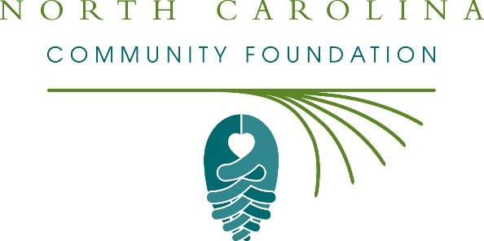
New Hanover nonprofits awarded $7,000 in Hurricane Florence recovery grants from the North Carolina Community Foundation Disaster Relief Fund
The board of advisors of the New Hanover Community Foundation was recently awarded $7,000 in recovery grants from the North Carolina Community Foundation Disaster Relief Fund to support the long-term recovery of the local community from Hurricane Florence. In April, an additional $49,000 was awarded to area nonprofits committed to long-term disaster recovery.
Grants received include:
- $1,400 to Brigade Boys & Girls Club of Wilmington
- $1,400 to Cape Fear Habitat for Humanity
- $1,400 to Family Promise of the Lower Cape Fear
- $1,400 to First Fruit Ministries
- $1,400 to Wilmington Area Rebuilding Ministry, Inc.
The grants were made from the NCCF Disaster Relief Fund’s initial grantmaking allocations to support long-term recovery and meet unmet needs from Hurricane Florence in New Hanover County.
“These grants are critical to the long-term recovery of New Hanover County from Hurricane Florence,” said Kristi Sullivan, NHCCF board president. “The North Carolina Community Foundation Disaster Relief Fund is a pivotal resource to our local community thanks to the generosity of many donors who gave to help eastern North Carolina.”
NCCF is keenly aware of how deeply Hurricane Florence impacted eastern North Carolina and devastated many communities in our state, according to Jennifer Tolle Whiteside, CEO and president. “The North Carolina Community Foundation has been in these communities for more than 30 years and will continue to be there supporting disaster recovery long after the TV cameras are gone,” she said. “We were grateful to see the outpouring of generosity that supported the NCCF Disaster Relief Fund and are honored to steward these funds to support long-term recovery efforts and meet unmet needs.”
About the New Hanover County Community Foundation
The New Hanover County Community Foundation is a growing family of philanthropic funds, source of grants for local causes and partner for donors. The NHCCF is a descendant of the former Community Foundation of Southeastern North Carolina, serving the community since 1987. NHCCF is led by a local volunteer advisory board that helps build community assets through the creation of permanent endowments, makes grants and leverages leadership – all for the benefit of New Hanover County.
The NHCCF is an affiliate of the North Carolina Community Foundation. In addition to Sullivan, board members include: Patrick Boykin (vice president), Justin Burgess (secretary), Charles Earney (treasurer), Jonathan Alper, Ned Barclay, Ronald Copley, Eldridge Dodson, Stephen Gaskins, Frank Gibson, Martin Green, Patrick Moore, Hollis Ray, Jane Rippy, Frankie Roberts and Anna Van Rens Taylor.
About the North Carolina Community Foundation
The NCCF is the single statewide community foundation serving North Carolina and has administered more than $145 million in grants since its inception in 1988. With more than $270 million in assets, NCCF sustains 1,300 endowments established to provide long-term support of a broad range of community needs, nonprofit organizations institutions and scholarships. The NCCF partners with a network of affiliate foundations to provide local resource allocation and community assistance across the state. An important component of NCCF’s mission is to ensure that rural philanthropy has a voice at local, regional and national levels.
For more information, visit nccommunityfoundation.org.

News media contact
Louis Duke, NCCF Senior Communications Specialist
919-256-6922, lduke@nccommunityfoundation.org

