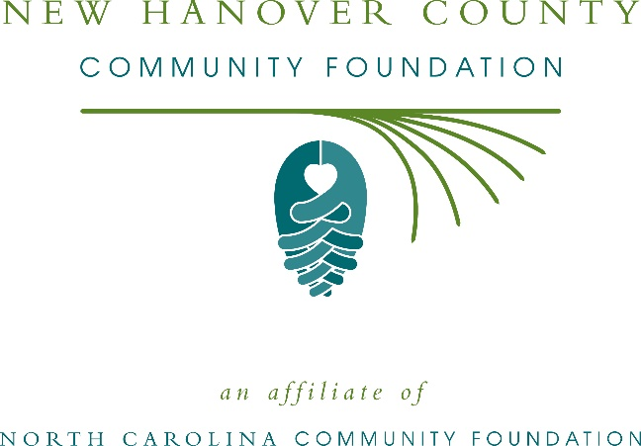
New Hanover County Community Foundation awards more than $50,000 in local grants
The board of advisors of the New Hanover County Community Foundation recently announced $50,860 in local grant awards from its community grantmaking fund, the Suzanne and George Taylor Endowment Fund, the 1898 Memorial Fund and the Lucille Murchison Marvin Fund, according to Kristi Sullivan, board president.
This year the board granted:
- $6,000 to The Carousel Center for general operating support
- $2,500 to Prevent Blindness North Carolina for Star Pupils New Hanover County
- $2,500 to Wilmington Family YMCA for Hurricane Relief- Childcare and Youth Development Programs
- $3,000 to Family Promise of the Lower Cape Fear for Families Forward Transitional Housing
- $2,500 to DREAMS of Wilmington, Inc. for Career-Readiness through Digital Music Production
- $7,000 to Cape Fear Guardian Ad Litem Association for “Help A Kid Be A Kid”
- $4,180 to “Bread for Life…” for enhanced nutrition program
- $4,000 to Community Enrichment Initiatives, Inc. for MLK Community Kitchen
- $6,680 to Assistance League of Greater Wilmington for Operation School Bell
- $4,500 for Good Shepherd Ministries of Wilmington, Inc. for Food Services
- $3,000 to Domestic Violence Shelter and Services, Inc. for general operating support
- $5,000 to Cape Fear Museum for 1898 Wilmington Race Riot Education
Sullivan thanked the community for its continued support of the New Hanover County Community Foundation. “We are proud to support these nonprofit programs that are so vital to the community,” she said. “We are grateful to the many generous individuals and organizations that have supported our work to inspire philanthropy across our community.”
For further information, contact NCCF Regional Director Anne Sorhagen at 910-202-6727 or asorhagen@nccommunityfoundation.org or visit the NCCF website at nccommunityfoundation.org.
About the New Hanover County Community Foundation
An affiliate of the North Carolina Community Foundation, the New Hanover County Community Foundation is a growing family of philanthropic funds, source of grants for local causes and partner for donors. The NHCCF is a descendant of the former Community Foundation of Southeastern North Carolina, serving the community since 1987. NHCCF is led by a local volunteer advisory board that helps build community assets through the creation of permanent endowments, makes grants and leverages leadership – all for the benefit of New Hanover County.
The NHCCF board advises the New Hanover County Community Foundation, the unrestricted community grantmaking fund, to support local needs. The competitive grants program is held on an annual basis. Advisory board members live and work in New Hanover County, positioning them to strategically leverage resources, meet local needs and access opportunities. In addition to Sullivan, board members include: Patrick Boykin (vice president), Justin Burgess (secretary), Charles Earney (treasurer), Jonathan Alper, Ned Barclay, Ronald Copley, Eldridge Dodson, Stephen Gaskins, Frank Gibson, Martin Green, Patrick Moore, Hollis Ray, Jane Rippy, Frankie Roberts and Anna Van Rens Taylor.
The New Hanover County Community Foundation, through the NC Community Foundation, makes it easy to become a philanthropist, whatever your means or charitable goals. You can open an endowment for your favorite cause at any time – or contribute to an existing fund in any amount. Tax-deductible contributions, made payable to the New Hanover County Community Foundation, can be mailed to the North Carolina Community Foundation, 3737 Glenwood Ave. Suite 460, Raleigh, NC 27612. Contributions can also be made online at nccommunityfoundation.org.
About the North Carolina Community Foundation
The NCCF is the single statewide community foundation serving North Carolina and has administered more than $145 million in grants since its inception in 1988. With more than $270 million in assets, NCCF sustains 1,300 endowments established to provide long-term support of a broad range of community needs, nonprofit organizations institutions and scholarships. The NCCF partners with a network of affiliate foundations to provide local resource allocation and community assistance across the state. An important component of NCCF’s mission is to ensure that rural philanthropy has a voice at local, regional and national levels.
For more information, visit nccommunityfoundation.org.
News media contact
Louis Duke, NCCF Senior Communications Specialist
919-256-6922, lduke@nccommunityfoundation.org

