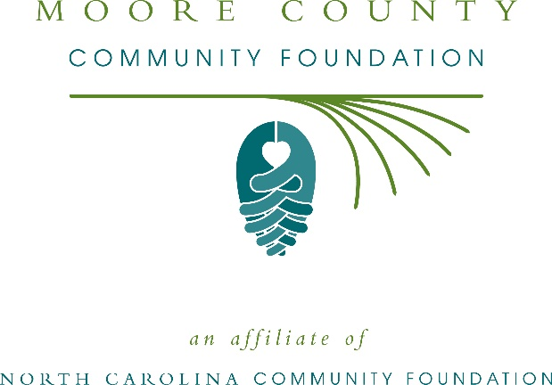
Moore County Community Foundation awards more than $107,000 in local grants
The board of advisors of the Moore County Community Foundation recently announced $107,741 in local grant awards from its community grantmaking fund, the John W. Roffe and Marjorie A. Roffe Endowment, the St. Joseph of the Pines Charitable Endowment for Moore County and the Robert L. and Marcia P. Ellis Endowment, according to Russell Sugg, board president.
This year the board granted:
- $1,500 to the American Red Cross Serving the Eastern NC Region for Moore County (Disaster Cycle Services)
- $1,000 Prevent Blindness North Carolina for Star Pupils Moore County
- $5,000 to the Arc of Moore County for family support programs
- $10,000 to Northern Moore Family Resource Center for HOPE Academy Preschool
- $1,500 to Girl Scouts- North Carolina Coastal Pines for Moore County Girl Scout Leadership Experience
- $2,000 to Drug Free Moore County for the Peer to Peer Support Program/Moore ReCreations Recovery Center
- $1,000 to Carolina Philharmonic for a 3-D printer for the STEAM project
- $2,000 to Sandhills Cooperation Association for the Moore Cooking Co-op
- $3,000 to Moore County Literacy Council for the Read Moore Academy for Summer
- $2,500 for Habitat for Humanity of the NC Sandhills, Inc. for domestic abuse survivor home building
- $5,000 to Sandhills/Moore Coalition for human care for emergency healthcare assistance
- $600 to the Foundation of FirstHealth – Clara McLean House for grocery store gift certificates for impoverished longer-term guests
- $3,500 to St. Joseph of the Pines for “Together We Can Do Moore” Fee Mobile Adult Dental Clinic
- $1,500 to Moore County Vietnam Veterans of America Chapter 966 for funding local veterans emergency needs
- $1,500 to MIRA Foundation USA, Inc. for guide dog pairing with visually impaired children
- $1,000 to Boys & Girls Club of the Sandhills for after school and summer programming
- $25,000 to Moore Free & Charitable Clinic for primary care and chronic disease management
- $1,500 to Sandhills Machine, Inc. for Sandhills Machine Youth Development
- $5,278 to Sandhills Sandsharks, Inc. for Dome Raising 2019
- $1,000 to Sandhills PRIDE for expansion and outreach efforts
- $2,500 to Ronald McDonald House of Chapel Hill for the Moore County Cares fund
- $7,000 to Friend to Friend for Project SAFE
- $2,602 to Sandhills Children’s Center for inclusive playground equipment
- $500 to the North Carolina Theatre Conference for NCTC High School Play Festival at Union Pines High School
- $1,500 to the Bethany House, Inc. for the Education Conference
- $2,500 to Autism Society of North Carolina for 2019-2020 Camp Royall scholarships
- $2,000 to Moore Buddies Mentoring for the My PATH program
- $1,500 to TROSA (Triangle Residential Options for Substance Abusers, Inc.) for Residential Substance Abuse Recovery Services for Individuals from Moore County
- $2,500 to Family Promise of Moore County for Client Assistance Fund for Emergency and Health Needs
- $2,000 to the North Carolina Symphony Society for Music Education Concert for Moore County Elementary Schools
- $5,000 to Prancing Horse, Inc. for support for individuals unable to participate in equine assisted programs
- $1,000 to MALES of Distinction for their Community Impact Program
- $2,261 to AIMS Authors in Moore Schools for general operating support
Sugg thanked the community for its continued support of the Moore County Community Foundation. “We are proud to support these nonprofit programs that are so vital to the community,” he said. “We are grateful to the many generous individuals and organizations that have supported our work to inspire philanthropy across our county.”
For further information, contact NCCF Regional Director Dawn Neighbors at 910-292-4437 or dneighbors@nccommunityfoundation.org or visit the NCCF website at nccommunityfoundation.org.
About the Moore County Community Foundation
An affiliate of the North Carolina Community Foundation, the Moore County Community Foundation is a growing family of philanthropic funds, source of grants for local causes and partner for donors. The MCCF was founded in 1991 and is led by a local volunteer advisory board that helps build community assets through the creation of permanent endowments, makes grants and leverages leadership – all for the benefit of Moore County.
The MCCF board advises the Moore County Community Foundation, the unrestricted community grantmaking fund, to support local needs. The competitive grants program is held on an annual basis. Advisory board members live and work in Moore County, positioning them to strategically leverage resources, meet local needs and access opportunities. In addition to Sugg, board members include: Peggy Sarvis (vice president), Claudia Miller (secretary), Ellen Airs, Betsy Best, Hugh Bingham, Kea Capel, Blanchie Carter, Brantley Clifton, Marilyn Grube, Olujide Lawal, Patricia Niebauer, Randall Phillips, Lori Portfleet, Tony Price, Alice Robbins, Pam Wase and Greg Zywockinski.
The Moore County Community Foundation, through the NC Community Foundation, makes it easy to become a philanthropist, whatever your means or charitable goals. You can open an endowment for your favorite cause at any time – or contribute to an existing fund in any amount. Tax-deductible contributions, made payable to the Moore County Community Foundation, can be mailed to the North Carolina Community Foundation, 3737 Glenwood Ave. Suite 460, Raleigh, NC 27612. Contributions can also be made online at nccommunityfoundation.org.
About the North Carolina Community Foundation
The NCCF is the single statewide community foundation serving North Carolina and has administered more than $145 million in grants since its inception in 1988. With more than $270 million in assets, NCCF sustains 1,300 endowments established to provide long-term support of a broad range of community needs, nonprofit organizations institutions and scholarships. The NCCF partners with a network of affiliate foundations to provide local resource allocation and community assistance across the state. An important component of NCCF’s mission is to ensure that rural philanthropy has a voice at local, regional and national levels.
For more information, visit nccommunityfoundation.org.
News media contact
Louis Duke, NCCF Senior Communications Specialist
919-256-6922, lduke@nccommunityfoundation.org

