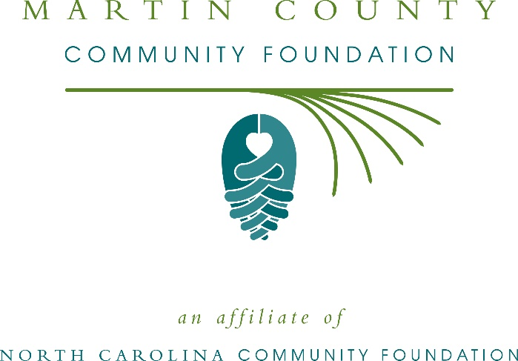
Martin County Community Foundation awards $1,500 in local grants
The board of advisors of the Martin County Community Foundation recently announced $1,500 in local grant awards from its community grantmaking fund, according to Lucia Peel, board president.
This year the board granted:
- $1,000 to the Boys & Girls Club of the Coastal Plain for Formula for Impact and county club maintenance
- $500 to the North Carolina Symphony Society for Music Discovery for Martin County Preschoolers
Peel thanked the community for its continued support of the Martin County Community Foundation. “We are proud to support these nonprofit programs that are so vital to the community,” she said. “We are grateful to the many generous individuals and organizations that have supported our work to inspire philanthropy across our community.”
For further information, contact NCCF Regional Director Natalie Jenkins Peel at 252-562-9824 or npeel@nccommunityfoundation.org or visit the NCCF website at nccommunityfoundation.org.
About the Martin County Community Foundation
An affiliate of the North Carolina Community Foundation, the Martin County Community Foundation is a growing family of philanthropic funds, source of grants for local causes and partner for donors. The MCCF was founded in 2004 and is led by a local volunteer advisory board that helps build community assets through the creation of permanent endowments, makes grants and leverages leadership – all for the benefit of Martin County.
The MCCF board advises the Martin County Community Foundation, the unrestricted community grantmaking fund, to support local needs. The competitive grants program is held on an annual basis. Advisory board members live and work in Martin County, positioning them to strategically leverage resources, meet local needs and access opportunities. In addition to Peel, board members include: Gary Sproat (vice president), Susan Dunlow (secretary), Mary Saunders (treasure), Loyall Corey, Deryl Fulmer, Simon Griffin, Leslie Johnson, Jerry McCrary and Nancy Winslow.
The Martin County Community Foundation, through the NC Community Foundation, makes it easy to become a philanthropist, whatever your means or charitable goals. You can open an endowment for your favorite cause at any time – or contribute to an existing fund in any amount. Tax-deductible contributions, made payable to the Martin County Community Foundation, can be mailed to the North Carolina Community Foundation, 3737 Glenwood Ave. Suite 460, Raleigh, NC 27612. Contributions can also be made online at nccommunityfoundation.org.
About the North Carolina Community Foundation
The NCCF is the single statewide community foundation serving North Carolina and has administered more than $145 million in grants since its inception in 1988. With more than $270 million in assets, NCCF sustains 1,300 endowments established to provide long-term support of a broad range of community needs, nonprofit organizations institutions and scholarships. The NCCF partners with a network of affiliate foundations to provide local resource allocation and community assistance across the state. An important component of NCCF’s mission is to ensure that rural philanthropy has a voice at local, regional and national levels.
For more information, visit nccommunityfoundation.org.
News media contact
Louis Duke, NCCF Senior Communications Specialist
919-256-6922, lduke@nccommunityfoundation.org

