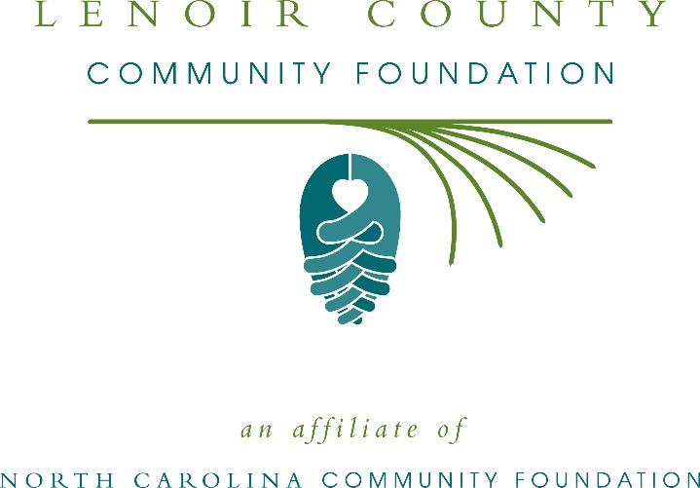
Lenoir County Community Foundation awards more than $8,000 in local grants
The board of advisors of the Lenoir County Community Foundation recently announced $8,600 in local grant awards from its community grantmaking fund and the Warren and Barbara Perry Fund, according to Frances Theodorakis, board president.
This year the board granted:
- $1,000 to Girl Scouts – North Carolina Coastal Pines for Lenoir County Girl Scout Leadership Experience
- $2,500 to Hope Restorations, Inc. for Hope Restorations Rebuilding Lives, Rebuilding East Kinston
- $800 to Kinston-Lenoir County Friends of the Library for Building STEM Skills in Lenoir County
- $1,050 to NC United Methodist Camp & Retreat Ministries, Inc. for stablishing a need-based scholarship for environmental education and teambuilding at Camp Don Lee
- $550 to Pink Hill Elementary for” In the Groove and On the Move”
- $1,200 to R.A.D.D., Inc. for their annual day trip
- $1,500 to the Young Women’s Outreach Center for the “Good GANG” Women Support Program
Theodorakis thanked the community for its continued support of the Lenoir County Community Foundation. “We are proud to support these nonprofit programs that are so vital to the community,” she said. “We are grateful to the many generous individuals and organizations that have supported our work to inspire philanthropy across our community.”
For further information, contact NCCF Regional Director Kim Ball at 252-288-5706 or kball@nccommunityfoundation.org or visit the NCCF website at nccommunityfoundation.org.
About the Lenoir County Community Foundation
An affiliate of the North Carolina Community Foundation, the Lenoir County Community Foundation is a growing family of philanthropic funds, source of grants for local causes and partner for donors. The LCCF was founded in 1993 and is led by a local volunteer advisory board that helps build community assets through the creation of permanent endowments, makes grants and leverages leadership – all for the benefit of Lenoir County.
The LCCF board advises the Lenoir County Community Foundation, the unrestricted community grantmaking fund, to support local needs. The competitive grants program is held on an annual basis. Advisory board members live and work in Lenoir County, positioning them to strategically leverage resources, meet local needs and access opportunities. In addition to Theodorakis, board members include: Jim Purnell (vice president), Jimmette Graham (secretary), Chris Henderson (treasurer), Tonya Adams, Greg Hannibal, Stephen Hill, Adrian King, John Marston, Joseph Rasberry, Caroline Roberts, Chris Segal, Sandy Skirving, Leraine Tolston, Michael Whitfield and Blaine Worthington.
The Lenoir County Community Foundation, through the NC Community Foundation, makes it easy to become a philanthropist, whatever your means or charitable goals. You can open an endowment for your favorite cause at any time – or contribute to an existing fund in any amount. Tax-deductible contributions, made payable to the Lenoir County Community Foundation, can be mailed to the North Carolina Community Foundation, 3737 Glenwood Ave. Suite 460, Raleigh, NC 27612. Contributions can also be made online at nccommunityfoundation.org.
About the North Carolina Community Foundation
The NCCF is the single statewide community foundation serving North Carolina and has administered more than $145 million in grants since its inception in 1988. With more than $270 million in assets, NCCF sustains 1,300 endowments established to provide long-term support of a broad range of community needs, nonprofit organizations institutions and scholarships. The NCCF partners with a network of affiliate foundations to provide local resource allocation and community assistance across the state. An important component of NCCF’s mission is to ensure that rural philanthropy has a voice at local, regional and national levels.
For more information, visit nccommunityfoundation.org.
News media contact
Louis Duke, NCCF Senior Communications Specialist
919-256-6922, lduke@nccommunityfoundation.org

