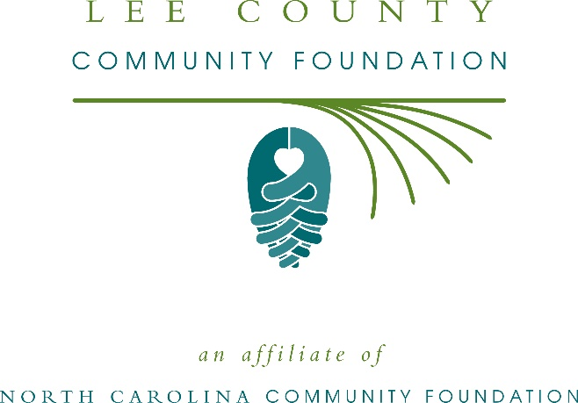
Lee County Community Foundation awards more than $19,000 in local grants
The board of advisors of the Lee County Community Foundation recently announced $19,500 in local grant awards from its community grantmaking fund, according to Mikeal Basinger, Jr., board president.
This year the board granted:
- $1,500 to the Boys & Girls Clubs of Central Carolina, Inc. for “CompuBotics”
- $2,500 to Central Carolina Community College for the Cougar Market
- $2,500 to Christian United Outreach Center of Lee County for Food for Lee County 2019
- $2,500 to El Refugio/The Refuge Family Resource Center for general operations
- $2,500 to Helping Hand Clinic for the Helping Hand Pharmacy Program
- $2,000 to Prevent Blindness North Carolina for Star Pupils Lee County
- $2,000 to Ronald McDonald House of Chapel Hill for the Lee County Cares Fund
- $2,500 to The Salvation Army of Lee County for Project CATCH (Community Action Targeting Children who are Homeless)
- $1,500 to TROSA (Triangle Residential Options for Substance Abusers, Inc.) for Residential Substance Abuse Recovery Services for Individuals from Lee County
Basinger thanked the community for its continued support of the Lee County Community Foundation. “We are proud to support these nonprofit programs that are so vital to the community,” she said. “We are grateful to the many generous individuals and organizations that have supported our work to inspire philanthropy across our community.”
For further information, contact NCCF Regional Director Dawn Neighbors at 910-292-4437 or dneighbors@nccommunityfoundation.org or visit the NCCF website at nccommunityfoundation.org.
About the Lee County Community Foundation
An affiliate of the North Carolina Community Foundation, the Lee County Community Foundation is a growing family of philanthropic funds, source of grants for local causes and partner for donors. The LCCF was founded in 1997 and is led by a local volunteer advisory board that helps build community assets through the creation of permanent endowments, makes grants and leverages leadership – all for the benefit of Lee County.
The LCCF board advises the Lee County Community Foundation, the unrestricted community grantmaking fund, to support local needs. The competitive grants program is held on an annual basis. Advisory board members live and work in Lee County, positioning them to strategically leverage resources, meet local needs and access opportunities. In addition to Basinger, board members include: Oscar Roberto (secretary), Mark Akinosho, Yvonne Bullard, S. Wilson Cox, Linda Foushee, Jan Hayes and David Spivey.
The Lee County Community Foundation, through the NC Community Foundation, makes it easy to become a philanthropist, whatever your means or charitable goals. You can open an endowment for your favorite cause at any time – or contribute to an existing fund in any amount. Tax-deductible contributions, made payable to the Lee County Community Foundation, can be mailed to the North Carolina Community Foundation, 3737 Glenwood Ave. Suite 460, Raleigh, NC 27612. Contributions can also be made online at nccommunityfoundation.org.
About the North Carolina Community Foundation
The NCCF is the single statewide community foundation serving North Carolina and has administered more than $145 million in grants since its inception in 1988. With more than $270 million in assets, NCCF sustains 1,300 endowments established to provide long-term support of a broad range of community needs, nonprofit organizations institutions and scholarships. The NCCF partners with a network of affiliate foundations to provide local resource allocation and community assistance across the state. An important component of NCCF’s mission is to ensure that rural philanthropy has a voice at local, regional and national levels.
For more information, visit nccommunityfoundation.org.
News media contact
Louis Duke, NCCF Senior Communications Specialist
919-256-6922, lduke@nccommunityfoundation.org

