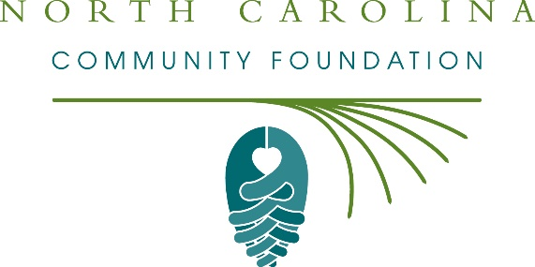
Jones County nonprofits awarded more than $26,000 in Hurricane Florence recovery grants from the North Carolina Community Foundation Disaster Relief Fund
The board of advisors of the Jones County Community Foundation recently awarded $26,250 in recovery grants from the North Carolina Community Foundation Disaster Relief Fund to support the long-term recovery of the local community from Hurricane Florence.
Grants received include:
- $8,750 to Jones County Community Development Corporation
- $8,750 to the Filling Station
- $8,750 to Jones County RISE
The grants were made from the NCCF Disaster Relief Fund’s initial grantmaking allocations to support long-term recovery and meet unmet needs from Hurricane Florence in Jones County.
“These grants are critical to the long-term recovery of Jones County from Hurricane Florence,” said Charles C. Jones III, JCCF board president. “The North Carolina Community Foundation Disaster Relief Fund is a pivotal resource to our local community thanks to the generosity of many donors who gave to help eastern North Carolina.”
NCCF is keenly aware of how deeply Hurricane Florence impacted eastern North Carolina and devastated many communities in our state, according to Jennifer Tolle Whiteside, CEO and president. “The North Carolina Community Foundation has been in these communities for more than 30 years and will continue to be there supporting disaster recovery long after the TV cameras are gone,” she said. “We were grateful to see the outpouring of generosity that supported the NCCF Disaster Relief Fund and are honored to steward these funds to support long-term recovery efforts and meet unmet needs.”
About the Jones County Community Foundation
The Jones County Community Foundation is a growing family of philanthropic funds, source of grants for local causes and partners for donors. The JCCF was founded in 2005 and is led by a local volunteer advisory board that helps build community assets through the creation of permanent endowments, makes grants and leverages leadership – all for the benefit of Jones County.
The JCCF is an affiliate of the North Carolina Community Foundation. In addition to Jones, board members include: Gloria Wiggins (vice president), Ivy Brantley Reid (secretary/treasurer), Victor Bryan, Jason Andrews, Eddie Banks, Allen Bender, Elois Body, Charles Henderson, Elwood Morris, Daniel Ryan, Joan Taylor, Michael Wilder and Wendy Winslow.
About the North Carolina Community Foundation
The NCCF is the single statewide community foundation serving North Carolina and has administered more than $145 million in grants since its inception in 1988. With more than $270 million in assets, NCCF sustains 1,300 endowments established to provide long-term support of a broad range of community needs, nonprofit organizations institutions and scholarships. The NCCF partners with a network of affiliate foundations to provide local resource allocation and community assistance across the state. An important component of NCCF’s mission is to ensure that rural philanthropy has a voice at local, regional and national levels.
For more information, visit nccommunityfoundation.org.
News media contact
Louis Duke, NCCF Senior Communications Specialist
919-256-6922, lduke@nccommunityfoundation.org

