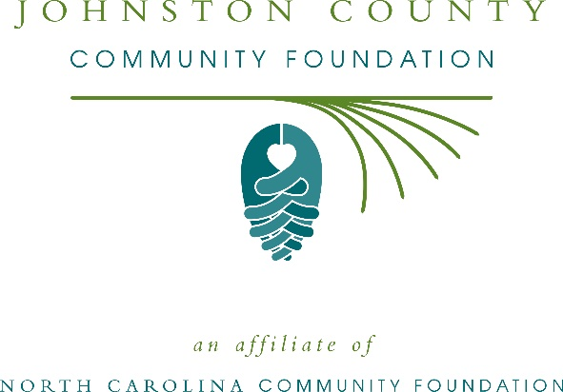
Johnston County Community Foundation awards more than $41,000 in local grants and scholarships
The board of advisors of the Johnston County Community Foundation recently announced $41,500 in local grant awards from its community grantmaking fund, the Cara Lee Powell Priest Endowment for Johnston County and the Lorraine Cooper Johnston County Community Foundation Endowment, according to Nancy Faber, board president.
This year the board granted:
- $2,500 to the Johnston County Heritage Center for collections Care
- $2,500 to With Love from Jesus Ministries for the food pantry
- $2,500 to Clayton Cultural Arts Foundation- Carolina Youth Theatre for their production of “The Wizard of Oz”
- $2,500 to Me Fine Foundation, Inc. for financial assistance and emotional support for children and families navigating a medical crisis
- $1,500 to Johnston County Animal Protection League, Inc. for the spay and neuter program renewal
- $1,000 to Prevent Blindness North Carolina for Star Pupils Johnston County
- $2,500 to the Johnston County Arts Council for Artists-in-the-Schools
- $2,000 to Johnston County Public Schools for Central Park South
- $2,500 to Benson Area Ministerial Association for BAMA Feeding and Community Assistance Program
- $2,500 to Kenly Area Ministries for general operations
- $2,000 to the Inter-Faith Food Shuttle for food support for at-risk Johnston County youth & families
- $2,500 to My Kid’s Club of Johnston County for STEM IT UP!
- $1,000 to Reach Out and Read for general operations
- $2,500 to Episcopal Farmworker Ministry for their Water in the Fields program
- $2,500 to Harbor, Inc. for a safe space
- $2,500 to Johnston-Lee-Harnett Community Action, Inc. for their Stars Soaring to Success program
- $1,500 to Partnership for Children of Johnston County for their program Safe Kids: Automobile Safety Education
- $2,500 to the Ronald McDonald House of Chapel Hill for the Johnston County Cares Fund
- $2,500 to Johnston County Youth Services, Inc. for general operations
The board also announced local scholarship recipients.
- The Ernestine J. Williams scholarship was awarded to:
- Linda Nurrito
- Brooke Burns
- Nathan Kiser
- Michael Aguilar
- Lindsay Hall
- The Fred M. Parrish, Jr. scholarship was awarded to:
- Nathan Kiser
- The Helen Tomlinson Hobart scholarship was awarded to:
- Ashlyn Hogg
- The Jefferson L. & Eva W. Sugg scholarship was awarded to:
- Nathan Kiser
- Hasana Muhammad
Faber thanked the community for its continued support of the Johnston County Community Foundation. “We are proud to support these nonprofit programs that are so vital to the community,” she said. “We are grateful to the many generous individuals and organizations that have supported our work to inspire philanthropy across our community.”
For further information, contact NCCF Grants Program Manager Christopher Fipps at 919-256-6923 or cfipps@nccommunityfoundation.org or visit the NCCF website at nccommunityfoundation.org.
About the Johnston County Community Foundation
An affiliate of the North Carolina Community Foundation, the Johnston County Community Foundation is a growing family of philanthropic funds, source of grants for local causes and partner for donors. The JCCF was founded in 1992 and is led by a local volunteer advisory board that helps build community assets through the creation of permanent endowments, makes grants and leverages leadership – all for the benefit of Johnston County.
The JCCF board advises the Johnston County Community Foundation, the unrestricted community grantmaking fund, to support local needs. The competitive grants program is held on an annual basis. Advisory board members live and work in Johnston County, positioning them to strategically leverage resources, meet local needs and access opportunities. In addition to Faber, board members include: Oliver Johnson (vice president), Emery Ashley, Wanda Blow, Don Boyette, Kevin Boyette, Gwen Canady, Lorine Davis, Margaret DiNubila, Bill Galloway, John Hobart, Robin Little, Laurie Partlo, Maritza Roosado, Betsy Whittington and James Wilson.
The Johnston County Community Foundation, through the NC Community Foundation, makes it easy to become a philanthropist, whatever your means or charitable goals. You can open an endowment for your favorite cause at any time – or contribute to an existing fund in any amount. Tax-deductible contributions, made payable to the Johnston County Community Foundation, can be mailed to the North Carolina Community Foundation, 3737 Glenwood Ave. Suite 460, Raleigh, NC 27612. Contributions can also be made online at nccommunityfoundation.org.
About the North Carolina Community Foundation
The NCCF is the single statewide community foundation serving North Carolina and has administered more than $145 million in grants since its inception in 1988. With more than $270 million in assets, NCCF sustains 1,300 endowments established to provide long-term support of a broad range of community needs, nonprofit organizations institutions and scholarships. The NCCF partners with a network of affiliate foundations to provide local resource allocation and community assistance across the state. An important component of NCCF’s mission is to ensure that rural philanthropy has a voice at local, regional and national levels.
For more information, visit nccommunityfoundation.org.
News media contact
Louis Duke, NCCF Senior Communications Specialist
919-256-6922, lduke@nccommunityfoundation.org

