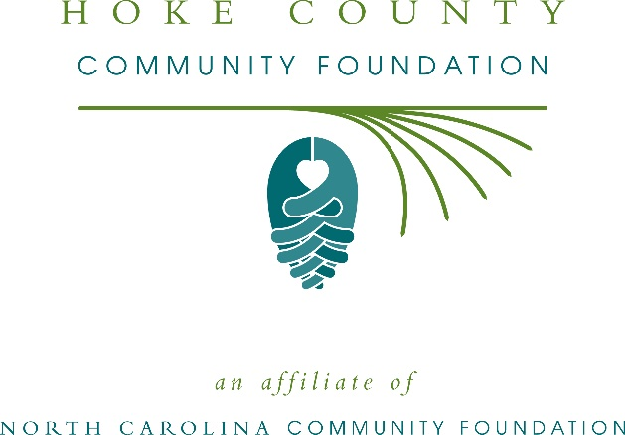
Hoke County Community Foundation awards more than $16,000 in local grants
The board of advisors of the Hoke County Community Foundation recently announced $16,390 in local grant awards from its community grantmaking fund and the Mary Archie NcNeill Endowment Fund, according to Ron Huff, board president.
This year the board granted:
- $1,500 to the American Red Cross Serving the Eastern NC Region for American Red Cross - Sandhills Chapter’s general operations
- $1,600 to the North Carolina Cooperative Extension, Hoke County 4-H for the 2019 Hoke County 4-H Summer Enrichment Program
- $1,000 to Prevent Blindness North Carolina for Star Pupils Hoke County
- $1,000 to Girl Scouts – North Carolina Coastal Pines for Hoke County Girl Scout Leadership Experience
- $1,500 to Hoke Reading/Literacy Council for Summer Reading Buddies 2019
- $2,000 Hoke County Open Door Soup Kitchen for their operations
- $3,000 to Hoke County Association for the Developmentally Disabled, Inc. for general operations
- $4,290 to Don Steed Elementary School for Music and Art: STEAMing Ahead!
- $500 to Children’s Cancer Partners of the Carolinas for Hoke County Childhood Cancer Safety Net
Huff thanked the community for its continued support of the Hoke County Community Foundation. “We are proud to support these nonprofit programs that are so vital to the community,” he said. “We are grateful to the many generous individuals and organizations that have supported our work to inspire philanthropy across our community.”
For further information, contact NCCF Regional Director Dawn Neighbors at 910-292-4437 or dneighbors@nccommunityfoundation.org or visit the NCCF website at nccommunityfoundation.org.

About the Hoke County Community Foundation
An affiliate of the North Carolina Community Foundation, the Hoke County Community Foundation is a growing family of philanthropic funds, source of grants for local causes and partner for donors. The HCCF was founded in 1998 and is led by a local volunteer advisory board that helps build community assets through the creation of permanent endowments, makes grants and leverages leadership – all for the benefit of Hoke County.
The HCCF board advises the Hoke County Community Foundation, the unrestricted community grantmaking fund, to support local needs. The competitive grants program is held on an annual basis. Advisory board members live and work in Hoke County, positioning them to strategically leverage resources, meet local needs and access opportunities. In addition to Huff, board members include: Wanda Cohen (vice president), Leah Leach (secretary/treasurer), David Edmundson, Jean Harrison, Candace Hayworth, John Jordan, Marshall Lyons, Jeff McNeill, Wanda McPhaul, Joseph Poole and Jodi Willis.
The Hoke County Community Foundation, through the NC Community Foundation, makes it easy to become a philanthropist, whatever your means or charitable goals. You can open an endowment for your favorite cause at any time – or contribute to an existing fund in any amount. Tax-deductible contributions, made payable to the Hoke County Community Foundation, can be mailed to the North Carolina Community Foundation, 3737 Glenwood Ave. Suite 460, Raleigh, NC 27612. Contributions can also be made online at nccommunityfoundation.org.
About the North Carolina Community Foundation
The NCCF is the single statewide community foundation serving North Carolina and has administered more than $145 million in grants since its inception in 1988. With more than $270 million in assets, NCCF sustains 1,300 endowments established to provide long-term support of a broad range of community needs, nonprofit organizations institutions and scholarships. The NCCF partners with a network of affiliate foundations to provide local resource allocation and community assistance across the state. An important component of NCCF’s mission is to ensure that rural philanthropy has a voice at local, regional and national levels.
For more information, visit nccommunityfoundation.org.
News media contact
Louis Duke, NCCF Senior Communications Specialist
919-256-6922, lduke@nccommunityfoundation.org

