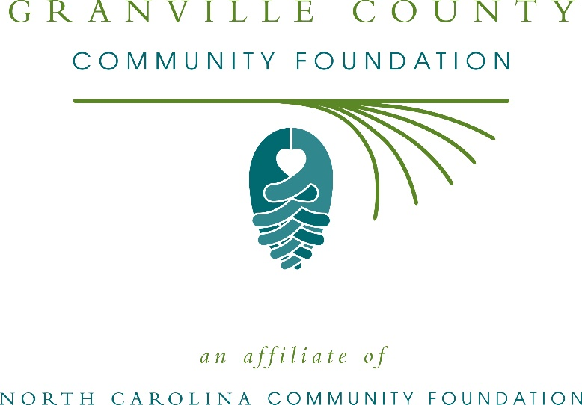
Granville County Community Foundation awards more than $17,000 in local grants
The board of advisors of the Granville County Community Foundation recently announced $17,165 in local grant awards from its community grantmaking fund, the Martha Frances Pruitt Endowment Fund, the Avery Legacy Fund and the Dr. and Mrs. C. Bryan Finch Endowment Fund, according to Betsy Stovall, board president.
This year the board granted:
- $1,000 to The American Red Cross Serving Eastern NC Region for Granville County Disaster Cycle Services
- $2,000 to Prevent Blindness North Carolina for Star Pupils Granville County
- $1,625 to Shepherd Youth Ranch for program marketing
- $3,000 to Granville County Local Organizing Committee Corp. for SWAG Tutorial Services
- $1,400 to Oak Hill Heritage House Museum and Research Library for expenses related to snacks and printed materials for Tutorial Connection: Each One, Reach One, Teach One
- $1,300 to The John Chavis Historical Society for facility rental and printing to host a multicultural festival featuring multicultural performers
- $3,100 to Granville County Extension Volunteer Association for Backpack Buddies
- $1,200 to the Autism Society of North Carolina for 2019-2020 Camp Royall Scholarships
- $1,540 to TROSA (Triangle Residential Options for Substance Abusers, Inc.) for residential substance abuse recovery services for individuals from Granville County
- $1,000 to the North Carolina Symphony Society for ensembles in the schools for Granville County students
Stovall thanked the community for its continued support of the Granville County Community Foundation. “We are proud to support these nonprofit programs that are so vital to the community,” she said. “We are grateful to the many generous individuals and organizations that have supported our work to inspire philanthropy across our community.”
For further information, contact NCCF Grants Program Manager Christopher Fipps at 919-256-6923 or cfipps@nccommunityfoundation.org or visit the NCCF website at nccommunityfoundation.org.
About the Granville County Community Foundation
An affiliate of the North Carolina Community Foundation, the Granville County Community Foundation is a growing family of philanthropic funds, source of grants for local causes and partner for donors. The GCCF was founded in 1997 and is led by a local volunteer advisory board that helps build community assets through the creation of permanent endowments, makes grants and leverages leadership – all for the benefit of Granville County.
The GCCF board advises the Granville County Community Foundation, the unrestricted community grantmaking fund, to support local needs. The competitive grants program is held on an annual basis. Advisory board members live and work in Granville County, positioning them to strategically leverage resources, meet local needs and access opportunities. In addition to Stovall, board members include: Dave Williams (grants chair), Roderick Allison, Everett Byrd, Gerald Lloyd, Harry Mills, Donna Ware, Rev. Richard Williams and Xavier Wortham.
The Granville County Community Foundation, through the NC Community Foundation, makes it easy to become a philanthropist, whatever your means or charitable goals. You can open an endowment for your favorite cause at any time – or contribute to an existing fund in any amount. Tax-deductible contributions, made payable to the Granville County Community Foundation, can be mailed to the North Carolina Community Foundation, 3737 Glenwood Ave. Suite 460, Raleigh, NC 27612. Contributions can also be made online at nccommunityfoundation.org.
About the North Carolina Community Foundation
The NCCF is the single statewide community foundation serving North Carolina and has administered more than $145 million in grants since its inception in 1988. With more than $270 million in assets, NCCF sustains 1,300 endowments established to provide long-term support of a broad range of community needs, nonprofit organizations institutions and scholarships. The NCCF partners with a network of affiliate foundations to provide local resource allocation and community assistance across the state. An important component of NCCF’s mission is to ensure that rural philanthropy has a voice at local, regional and national levels.
For more information, visit nccommunityfoundation.org.
News media contact
Louis Duke, NCCF Senior Communications Specialist
919-256-6922, lduke@nccommunityfoundation.org

