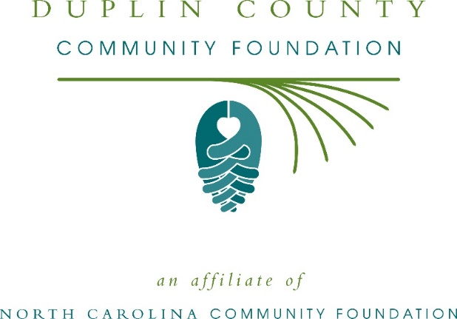
Duplin County Community Foundation awards more than $6,000 in local grants
The board of advisors of the Duplin County Community Foundation recently announced $6,545 in local grant awards from its community grantmaking fund, according to Bob Kornegay, board president.
This year the board granted:
- $1,000 to Prevent Blindness North Carolina for Duplin County Star Pupils
- $1,000 to Pet Friends of Duplin County for Low Cost Spay/Neuter Program
- $750 to Girl Scouts – North Carolina Coastal Pines for Duplin County Community Outreach Program
- $1,000 to Duplin County Sheriff’s Office DARE Program for general operational support
- $800 to Duplin Christian Outreach Ministries for DCOM/Feed Our Hungry Children/Summer Backpacks
- $795 to Rones Chapel Area Community Center (RCACC) for Child Safety Background Investigation (BI) Cost Support
- $750 to Mediation Center of Eastern Carolina – Duplin for MCEC Duplin Youth Enrichment: Peace Garden
- $450 to North Carolina Symphony Society for Music Discovery for Duplin County Preschoolers
Kornegay thanked the community for its continued support of the Duplin County Community Foundation. “We are proud to support these nonprofit programs that are so vital to the community,” he said. “We are grateful to the many generous individuals and organizations that have supported our work to inspire philanthropy across our community.”
For further information, contact NCCF Regional Director Anne Sorhagen at 910-202-6727 or asorhagen@nccommunityfoundation.org or visit the NCCF website at nccommunityfoundation.org.

About the Duplin County Community Foundation
An affiliate of the North Carolina Community Foundation, the Duplin County Community Foundation is a growing family of philanthropic funds, source of grants for local causes and partner for donors. The Duplin CCF was founded in 2005 and is led by a local volunteer advisory board that helps build community assets through the creation of permanent endowments, makes grants and leverages leadership – all for the benefit of Duplin County.
The Duplin CCF board advises the Duplin County Community Foundation, the unrestricted community grantmaking fund, to support local needs. The competitive grants program is held on an annual basis. Advisory board members live and work in Duplin County, positioning them to meet local needs. In addition to Kornegay, board members include: Debra Morrisey (vice president), Jayme Jones (treasurer), Brittainy Kildow (secretary), Wayne Branch, Kimberly Butler, Francisco Diaz, Ed Emory, Todd Minchew, Linda Smith and Florence Webb-Becton.
The Duplin County Community Foundation, through the NC Community Foundation, makes it easy to become a philanthropist, whatever your means or charitable goals. You can open an endowment for your favorite cause at any time – or contribute to an existing fund in any amount. Tax-deductible contributions, made payable to the Duplin County Community Foundation, can be mailed to the North Carolina Community Foundation, 3737 Glenwood Ave. Suite 460, Raleigh, NC 27612. Contributions can also be made online at nccommunityfoundation.org.
About the North Carolina Community Foundation
The NCCF is the single statewide community foundation serving North Carolina and has administered more than $145 million in grants since its inception in 1988. With more than $270 million in assets, NCCF sustains 1,300 endowments established to provide long-term support of a broad range of community needs, nonprofit organizations institutions and scholarships. The NCCF partners with a network of affiliate foundations to provide local resource allocation and community assistance across the state. An important component of NCCF’s mission is to ensure that rural philanthropy has a voice at local, regional and national levels.
For more information, visit nccommunityfoundation.org.
News media contact
Louis Duke, NCCF Senior Communications Specialist
919-256-6922, lduke@nccommunityfoundation.org

