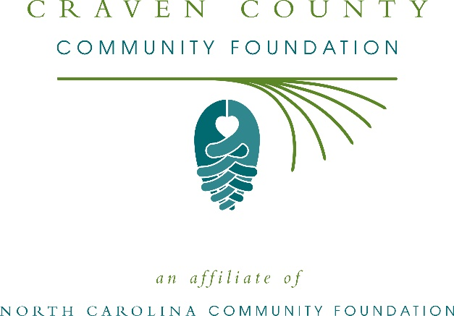
Craven County Community Foundation awards more than $185,000 in local grants
The board of advisors of the Craven County Community Foundation recently announced $185,936 in local grant awards from its community grantmaking fund, the Richard Chapman Cleve Fund, the Harry and Virginia Killian Charitable Endowment, and the Brian Fisher Endowment, according to Jonathan Segal, board president.
This year the board granted:
- $10,000 to Reviving Lives Ministries of New Bern, Inc. for their 12 Step Addiction Recovery Program
- $7,500 to Craven Literacy Council for Literacy Matters
- $15,000 to Boys & Girls Clubs of the Coastal Plain for Formula for Impact
- $4,000 to Prevent Blindness North Carolina for Star Pupils Craven County
- $15,000 to Coastal Women’s Shelter Inc. for operational support and relocation assistance for victims of domestic violence
- $1,050 to NC United Methodist Camp & Retreat Ministries for establishing a need-based scholarship for environmental education and teambuilding at camp Don Lee
- $10,000 to Community Coalition Against Family Violence/Promise Place for Trauma Focused Therapy Mental Health Program
- $9,500 to Catholic Diocese of Raleigh for Senior Pharmacy Program
- $1,500 to Special Olympics North Carolina for Special Olympics North Carolina – Craven County
- $1,500 to Craven Smart Start for Kindergarten Readiness Kits
- $5,000 to Sound Rivers, Inc. for Craven County Schools: Restoration and Education
- $15,000 to Religious Community Services for Perishable and Prepared Food Recovery
- $960 to New Bern High School Robotics Club for the Digital Notebook Future
- $3,500 to Reach Out and Read for Reach Out and Read – Craven County
- $10,000 to Food Bank of Central and Eastern North Carolina, Inc. for Feeding Families, Fueling Futures
- $7,073 to Backpack Blessings, Inc. for Backpack Blessings “Holiday Blessings”
- $1,000 to Autism Society of North Carolina for the 2019-2020 Camp Royall Scholarships
- $15,000 to MERCI Clinic for Primary Care
- $10,000 to New Bern Band Club, Inc. for the drum project
- $5,000 to TROSA (Triangle Residential Options for Substance Abusers, Inc.) for residential substance abuse recovery services for individuals from Craven County
- $12,000 to the Eastern Carolina Young Men’s Christian Association for the 2019 Twin Rivers YMCA Ned Based Day Camp Scholarships
- $5,000 to Brinson Memorial Elementary PTA Project Playground for Swinging into Success
- $3,000 to North Carolina Symphony Society for Ensembles in the Schools for Craven County Elementary Students
- $1,500 to Children’s Cancer Partners of the Carolinas for Craven County Childhood Cancer Safety Net
- $7,500 to Craven County Partners in Education for Today’s Learners, Tomorrow’s Leader in Me
- $9,353 to Craven County Partners in Education for Graphing Calculators for Havelock High – Hand Held Technology
Segal thanked the community for its continued support of the Craven County Community Foundation. “We are proud to support these nonprofit programs that are so vital to the community,” he said. “We are grateful to the many generous individuals and organizations that have supported our work to inspire philanthropy across our community.”
For further information, contact NCCF Regional Director Kim Ball at 252-288-5706 or kball@nccommunityfoundation.org or visit the NCCF website at nccommunityfoundation.org.
About the Craven County Community Foundation
An affiliate of the North Carolina Community Foundation, the Craven County Community Foundation is a growing family of philanthropic funds, source of grants for local causes and partner for donors. The CCCF was founded in 1991 and is led by a local volunteer advisory board that helps build community assets through the creation of permanent endowments, makes grants and leverages leadership – all for the benefit of Craven County.
The CCCF board advises the Craven County Community Foundation, the unrestricted community grantmaking fund, to support local needs. The competitive grants program is held on an annual basis. Advisory board members live and work in Craven County, positioning them to strategically leverage resources, meet local needs and access opportunities. In addition to Segal, board members include: Dr. James Congleton (vice president), Peter Moeller (secretary), Lee Knott (treasurer), Tyler Harris, James Briley, Martha Cook, James Davis, Dorothy Dove, Marc Finlayson, John Haroldson, John King, John Kirkland, Ken McCotter, Chuck Meekins, Gregory Peacock, Dan Pritchett, Dan Roberts, Tony Salem, Linda Staunch, Brian Taylor, Scott Thomas, Alice Tolson, Susan Ward and Rex Willis.
The Craven County Community Foundation, through the NC Community Foundation, makes it easy to become a philanthropist, whatever your means or charitable goals. You can open an endowment for your favorite cause at any time – or contribute to an existing fund in any amount. Tax-deductible contributions, made payable to the Craven County Community Foundation, can be mailed to the North Carolina Community Foundation, 3737 Glenwood Ave. Suite 460, Raleigh, NC 27612. Contributions can also be made online at nccommunityfoundation.org.
About the North Carolina Community Foundation
The NCCF is the single statewide community foundation serving North Carolina and has administered more than $145 million in grants since its inception in 1988. With more than $270 million in assets, NCCF sustains 1,300 endowments established to provide long-term support of a broad range of community needs, nonprofit organizations institutions and scholarships. The NCCF partners with a network of affiliate foundations to provide local resource allocation and community assistance across the state. An important component of NCCF’s mission is to ensure that rural philanthropy has a voice at local, regional and national levels.
For more information, visit nccommunityfoundation.org.
News media contact
Louis Duke, NCCF Senior Communications Specialist
919-256-6922, lduke@nccommunityfoundation.org

