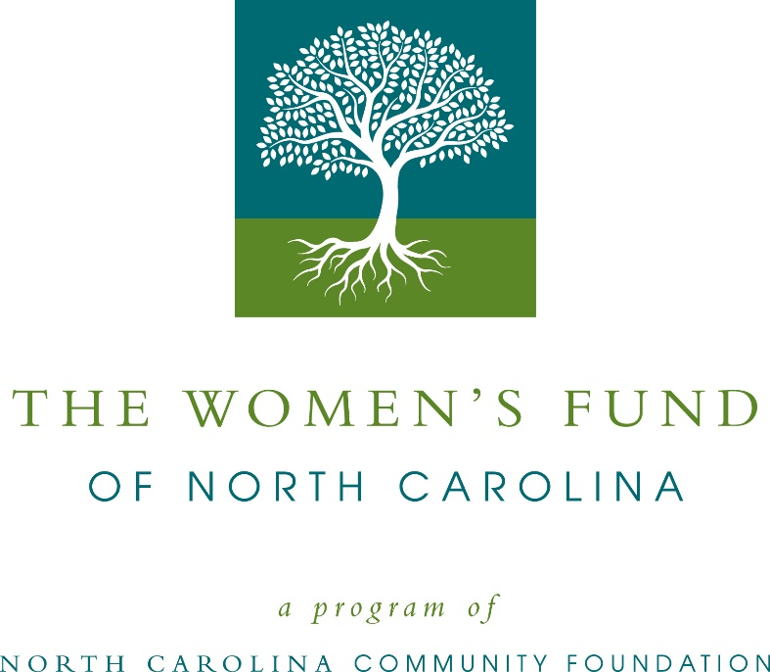
Community grants available from the Women’s Fund of North Carolina
The North Carolina Community Foundation is accepting grant applications for projects funded from the Women’s Fund of North Carolina, according to Jennifer Tolle Whiteside, NCCF president and CEO.
Grant funds are available for nonprofit organizations that sponsor programming that supports women and/or families, with emphasis on women’s health, job skill and career development and leadership. Programs must serve areas within the NCCF affiliate network. Applications are available beginning July 5. Visit nccommunityfoundation.org for information about applying. The deadline for submitting applications is noon August 6.
The grants committee of the Women’s Fund of North Carolina is comprised of representatives of NCCF’s local women’s giving networks and other female community leaders from across North Carolina. NCCF supports nine regionally based giving programs across the state.
“The Women’s Fund of North Carolina is dedicated to improving the quality of life for women, girls and families across the state,” said Tolle Whiteside. “This fund creates a unique opportunity to encourage philanthropic giving among women, for women.”
For further information, contact NCCF Grants Program Manager Christopher Fipps at 919-256-6923 or cfipps@nccommunityfoundation.org or visit the NCCF website at nccommunityfoundation.org.
About the North Carolina Community Foundation
The NCCF is the single statewide community foundation serving North Carolina and has administered more than $145 million in grants since its inception in 1988. With more than $270 million in assets, NCCF sustains 1,300 endowments established to provide long-term support of a broad range of community needs, nonprofit organizations institutions and scholarships. The NCCF partners with a network of affiliate foundations to provide local resource allocation and community assistance across the state. An important component of NCCF’s mission is to ensure that rural philanthropy has a voice at local, regional and national levels.
For more information, visit nccommunityfoundation.org.
News media contact
Louis Duke, NCCF Senior Communications Specialist
919-256-6922, lduke@nccommunityfoundation.org

