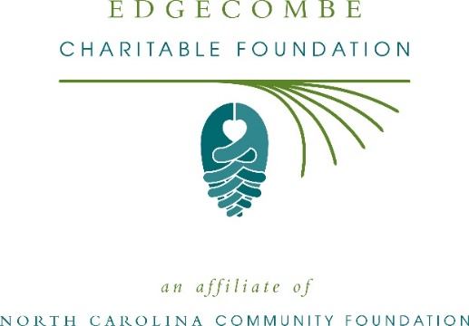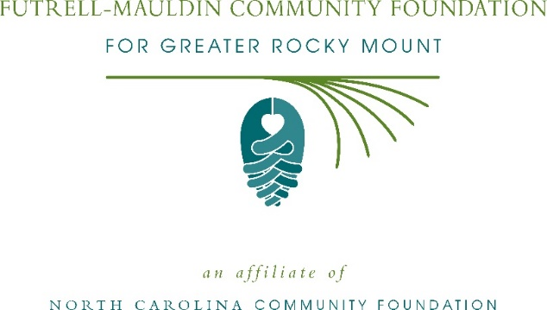
Community grants available from the Futrell-Mauldin Community Foundation for Greater Rocky Mount and the Edgecombe Charitable Foundation
The board of advisors of the Futrell-Mauldin Community Foundation and the Edgecombe Charitable Foundation are currently accepting grant applications from area nonprofits that serve general needs in the local community.
Funds are available for nonprofit organizations that serve general community needs in Nash and Edgecombe counties. Grants will be awarded from the community grantmaking funds and in Edgecombe County, from the Mary Ferebee Howard Endowment Fund. Applications are available online beginning July 12. Visit nccommunityfoundation.org for information about applying. The deadline for applications is noon August 13.
“This is a great opportunity for local nonprofits to expand their impact in our community,” said Sam Johnson, FMCF board president.
“We are excited to partner with nonprofit leaders to create lasting change in the community,” said Jane Thorne, ECF board president.
For further information, contact NCCF Regional Director Kelly Lee at 252-557-0278 or klee@nccommunityfoundation.org or visit the NCCF website at nccommunityfoundation.org.
About the Futrell-Mauldin Community Foundation and the Edgecombe Charitable Foundation
Affiliates of the North Carolina Community Foundation, the Futrell-Mauldin Community Foundation and the Edgecombe Charitable Foundation are growing families of philanthropic funds, sources of grants for local causes and partners for donors. The FMCF was founded in 1998 while the ECF was founded in 1995. They are led by separate local advisory boards that help build their respective community assets through the creation of permanent endowments, make grants and leverage leadership—all for the benefit of the Rocky Mount area and Edgecombe county.
THE FMCF board advises the Futrell-Mauldin Community Fund while the ECF board advises the Edgecombe Community Fund, both being unrestricted community grantmaking funds, to support local needs. The competitive grants programs are held on an annual basis. Since advisory board members live and work in Nash and Edgecombe counties, they can leverage resources to help meet local needs and access opportunities.

In addition to Johnson, Futrell-Mauldin board members include: Deborah Sperati (vice president), Sheila Martin (secretary), Sally Adams, Thomas Betts, Angela Burton, Mark Daley, Annie Daughtridge, Richard Futrell, Kevin Harris, Gloria Wiggins-Hicks, William Kincheloe, Celeste Pittman, Monica Seaman, Braxton Townsend and Elizabeth Turnage.
In addition to Thorne, ECF board members include: Mary Jane Jenkins (vice president), Laura Temple (secretary), Jim Marrow (grants chair), Thomas Anderson, Alison Blodgett, Joy Chafin, W.G. Clark, Carol Cobb, Jerome Creech, Anthony Edwards, Jamilla Hawkins, Linda Knight, Anne Lewis, Michael Peters, Mears Pitt and Margaret-Anne Wooten.
The Futrell-Mauldin County Community Foundation and the Edgecombe Community Fund, through the NC Community Foundation, make it easy to become a philanthropist, whatever your means or charitable goals. You can open an endowment for your favorite cause at any time – or contribute to an existing fund in any amount. Tax-deductible contributions, made payable to either the Futrell-Mauldin County Community Foundation or the Edgecombe Community Fund, can be mailed to the North Carolina Community Foundation, 3737 Glenwood Ave. Suite 460, Raleigh, NC 27612. Contributions can also be made online at nccommunityfoundation.org.
About the North Carolina Community Foundation
The NCCF is the single statewide community foundation serving North Carolina and has administered more than $145 million in grants since its inception in 1988. With more than $270 million in assets, NCCF sustains 1,300 endowments established to provide long-term support of a broad range of community needs, nonprofit organizations institutions and scholarships. The NCCF partners with a network of affiliate foundations to provide local resource allocation and community assistance across the state. An important component of NCCF’s mission is to ensure that rural philanthropy has a voice at local, regional and national levels.
For more information, visit nccommunityfoundation.org.
News media contact
Louis Duke, NCCF Senior Communications Specialist
919-256-6922, lduke@nccommunityfoundation.org

