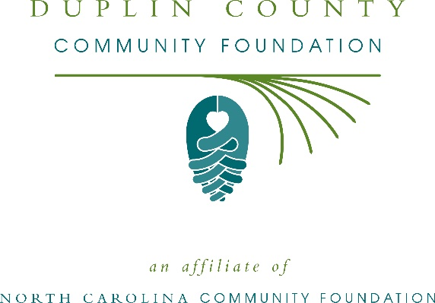
Community grants available from the Duplin Foundation for Youth Advancement
The board of advisors of the Duplin Foundation for Youth Advancement is currently accepting grant applications from area nonprofits focusing on youth in the local community.
Funds are available for nonprofit organizations in Duplin county. Priority is given to proposals that incorporate a holistic approach and include one or more of the following focus areas:
- Motivate youth to stay and succeed in school
- Foster positive youth-adult engagement through mentoring
- Strengthen gang awareness and prevention efforts
- Promote participation in philanthropy
- Provide leadership opportunities and employment skills training
- Increase likelihood of a successful transition to adulthood
- Develop financial literacy
- Encourage engagement in community service
- Promote mental and physical health and well-being
Applications are available online beginning June 28. Visit nccommunityfoundation.org for information about applying. The deadline for applications is noon July 30.
“This is a great opportunity for local nonprofits to expand their impact in our community,” said Bob Kornegay, Duplin County Community Foundation board president. “We are excited to partner with nonprofit leaders to create lasting change in the community.”
For further information, contact NCCF Regional Director Anne Sorhagen at 910-202-6727 or asorhagen@nccommunityfoundation.org or visit the NCCF website at nccommunityfoundation.org.
The Duplin Foundation for Youth Advancement is a fund of the Duplin County Community Foundation, an affiliate of the North Carolina Community Foundation. The Duplin County Community Foundation is a growing family of philanthropic funds, source of grants for local causes and partners for donors. The DCCF was founded in 2005 and is led by a local volunteer advisory board that helps build community assets through the creation of permanent endowments, makes grants and leverages leadership – all for the benefit of Duplin County.
The Duplin County Community Foundation, through the NC Community Foundation, makes it easy to become a philanthropist, whatever your means or charitable goals. You can open an endowment for your favorite cause at any time – or contribute to an existing fund in any amount. Tax-deductible contributions, made payable to the Duplin County Community Foundation, can be mailed to the North Carolina Community Foundation, 3737 Glenwood Ave. Suite 460, Raleigh, NC 27612. Contributions can also be made online at nccommunityfoundation.org.
About the North Carolina Community Foundation
The NCCF is the single statewide community foundation serving North Carolina and has administered more than $145 million in grants since its inception in 1988. With more than $270 million in assets, NCCF sustains 1,300 endowments established to provide long-term support of a broad range of community needs, nonprofit organizations institutions and scholarships. The NCCF partners with a network of affiliate foundations to provide local resource allocation and community assistance across the state. An important component of NCCF’s mission is to ensure that rural philanthropy has a voice at local, regional and national levels.
For more information, visit nccommunityfoundation.org.
News media contact
Louis Duke, NCCF Senior Communications Specialist
919-256-6922, lduke@nccommunityfoundation.org

