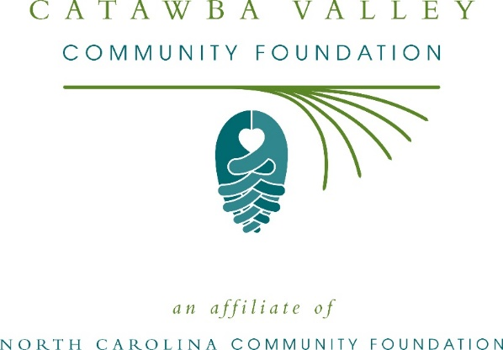
Community grants available from the Catawba Valley Community Foundation
The board of advisors of the Catawba Valley Community Foundation is currently accepting grant applications from area nonprofits that serve general needs in the local community. Special consideration will be given to applications that focus on early childhood development, mental health and substance abuse.
Funds are available for nonprofit organizations that serve general community needs in Caldwell, Alexander and Catawba counties. Grants will be awarded from the community grantmaking fund. Applications are available online beginning July 19. Visit nccommunityfoundation.org for information about applying. The deadline for applications is noon Aug. 20.
“We are excited to offer this funding opportunity to our nonprofit partners,” said Tamara Coley, CVCF board president. “Catawba Valley has a vibrant nonprofit community, and we look forward to supporting their endeavors to better our wonderful community.”
For further information, contact NCCF Regional Director Colby Martin at 828-358-0030 or cmartin@nccommunityfoundation.org or visit the NCCF website at nccommunityfoundation.org.
About the Catawba Valley Community Foundation
An affiliate of the North Carolina Community Foundation, the Catawba Valley Community Foundation is a growing family of philanthropic funds, source of grants for local causes and partners for donors. The CVCF was founded in 1997 and is led by a local volunteer advisory board that helps build community assets through the creation of permanent endowments, makes grants and leverages leadership – all for the benefit of Caldwell, Alexander and Catawba counties.
The CVCF board advises the Catawba Valley Community Foundation Fund, the unrestricted community grantmaking fund, to support local needs. This competitive grants program is held on an annual basis. Since advisory board members live and work in the Catawba Valley community, they can leverage resources to help meet local needs and access opportunities. In addition to Coley, board members include: Michelle Kirby (vice president), Lilly Skok Bunch (secretary), Suzan Anderson, Alex Bernhardt, Becky Gibbons, Gary Herman, Mandy Pitts-Hildebrand, Brice Melton, Jamie Treadaway, Beth Rogers and John Teeter.
The Catawba Valley Community Foundation, through the NC Community Foundation, makes it easy to become a philanthropist, whatever your means or charitable goals. You can open an endowment for your favorite cause at any time – or contribute to an existing fund in any amount. Tax-deductible contributions, made payable to the Catawba Valley Community Foundation, can be mailed to the North Carolina Community Foundation, 3737 Glenwood Ave. Suite 460, Raleigh, NC 27612. Contributions can also be made online at nccommunityfoundation.org.
About the North Carolina Community Foundation
The NCCF is the single statewide community foundation serving North Carolina and has administered more than $145 million in grants since its inception in 1988. With more than $270 million in assets, NCCF sustains 1,300 endowments established to provide long-term support of a broad range of community needs, nonprofit organizations institutions and scholarships. The NCCF partners with a network of affiliate foundations to provide local resource allocation and community assistance across the state. An important component of NCCF’s mission is to ensure that rural philanthropy has a voice at local, regional and national levels.
For more information, visit nccommunityfoundation.org.

News media contact
Louis Duke, NCCF Senior Communications Specialist
919-256-6922, lduke@nccommunityfoundation.org

