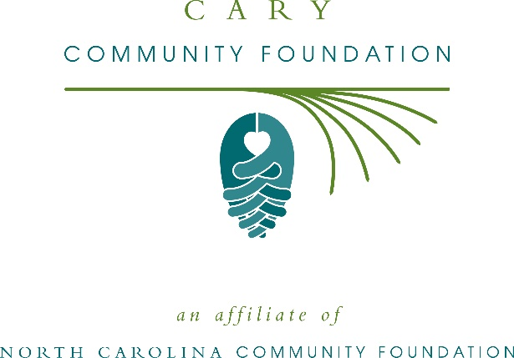
Community grants available from the Cary Community Foundation
The board of advisors of the Cary Community Foundation is currently accepting grant applications from area nonprofits that serve general needs in the local community.
Funds are available for nonprofit organizations that serve general community needs in Cary. Grants will be awarded from the community grantmaking fund. Applications are available online beginning June 28. Visit nccommunityfoundation.org for information about applying. The deadline for applications is noon July 30.
“This is a great opportunity for local nonprofits to expand their impact in our community,” said Laura Martin, CCF board president. “We are excited to partner with nonprofit leaders to create lasting change in the community.”
For further information, contact NCCF Grants Program Manager Christopher Fipps at 919-256-6923 or cfipps@nccommunityfoundation.org or visit the NCCF website at nccommunityfoundation.org.
About the Cary Community Foundation
An affiliate of the North Carolina Community Foundation, the Cary Community Foundation is a growing family of philanthropic funds, source of grants for local causes and partners for donors. The CCF was founded in 2006 and is led by a local volunteer advisory board that helps build community assets through the creation of permanent endowments, makes grants and leverages leadership – all for the benefit of Cary.
The CCF board advises the Cary Community Fund, the unrestricted community grantmaking fund, to support local needs. This competitive grants program is held on an annual basis. Since advisory board members live and work in Cary community, they can leverage resources to help meet local needs and access opportunities. In addition to Martin, board members include: Mike Stellpflug (secretary), Debbie Fox, Catherine Nguyen Pham, Simmi Prasad, Prity Shah and Sarah Stoeckel.
The Cary Community Foundation, through the NC Community Foundation, makes it easy to become a philanthropist, whatever your means or charitable goals. You can open an endowment for your favorite cause at any time – or contribute to an existing fund in any amount. Tax-deductible contributions, made payable to the Cary Community Foundation, can be mailed to the North Carolina Community Foundation, 3737 Glenwood Ave. Suite 460, Raleigh, NC 27612. Contributions can also be made online at nccommunityfoundation.org.
About the North Carolina Community Foundation
The NCCF is the single statewide community foundation serving North Carolina and has administered more than $145 million in grants since its inception in 1988. With more than $270 million in assets, NCCF sustains 1,300 endowments established to provide long-term support of a broad range of community needs, nonprofit organizations institutions and scholarships. The NCCF partners with a network of affiliate foundations to provide local resource allocation and community assistance across the state. An important component of NCCF’s mission is to ensure that rural philanthropy has a voice at local, regional and national levels.
For more information, visit nccommunityfoundation.org.
News media contact
Louis Duke, NCCF Senior Communications Specialist
919-256-6922, lduke@nccommunityfoundation.org

