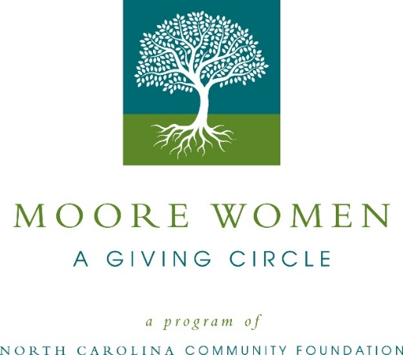
Community grants available from Moore Women – A Giving Circle
Moore Women – A Giving Circle is currently accepting grant applications for project funding.
Funds are available for nonprofit organizations that serve the needs of women and/or children in areas of health, education and human services in Moore County. Grants typically range from $500 to $5,000 with an average annual total granting amount of $20,000. Applications are available online beginning July 19. Visit nccommunityfoundation.org for more information about applying. The deadline for applications is noon August 20.
For further information, contact NCCF Regional Director Dawn Neighbors at 910-292-4437 or dneighbors@nccommunityfoundation.org or visit the NCCF website at nccommunityfoundation.org.
About the North Carolina Community Foundation
The NCCF is the single statewide community foundation serving North Carolina and has administered more than $145 million in grants since its inception in 1988. With more than $270 million in assets, NCCF sustains 1,300 endowments established to provide long-term support of a broad range of community needs, nonprofit organizations institutions and scholarships. The NCCF partners with a network of affiliate foundations to provide local resource allocation and community assistance across the state. An important component of NCCF’s mission is to ensure that rural philanthropy has a voice at local, regional and national levels.
For more information, visit nccommunityfoundation.org.
News media contact
Louis Duke, NCCF Senior Communications Specialist
919-256-6922, lduke@nccommunityfoundation.org

