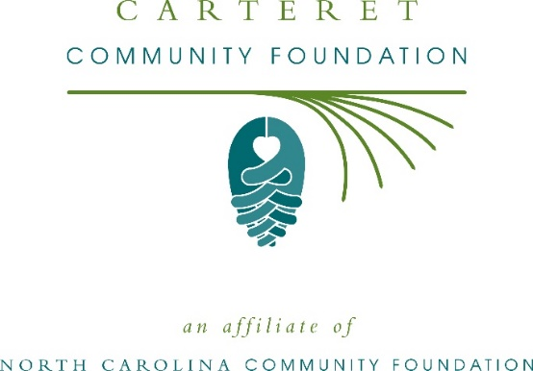
Community grants available from Carteret Community Foundation and Pearl’s Pantry Fund
The board of advisors of the Carteret Community Foundation is currently accepting grant applications for the Pearl’s Pantry Fund and the community grantmaking fund.
Funds are available for nonprofit organizations that serve general community needs in Carteret County. Grants will be awarded from the community grantmaking fund and the Pearl’s Pantry Fund. Applications are available online beginning July 19. Visit nccommunityfoundation.org for information about applying. The deadline for applications is noon Aug. 20.
“We are excited to offer this funding opportunity to our nonprofit partners,” said Terry Robertson, CCF board president. “Carteret has a vibrant nonprofit community, and we look forward to supporting their endeavors to better our wonderful county.”
For further information, contact NCCF Regional Director Kim Ball at 252-288-5706 or kball@nccommunityfoundation.org or visit the NCCF website at nccommunityfoundation.org.
About the Carteret Community Foundation
An affiliate of the North Carolina Community Foundation, the Carteret Community Foundation is a growing family of philanthropic funds, source of grants for local causes and partners for donors. The CCF was founded in 2005 and is led by a local volunteer advisory board that helps build community assets through the creation of permanent endowments, makes grants and leverages leadership – all for the benefit of Carteret County.
The CCF board advises the Carteret Community Foundation, the unrestricted community grantmaking fund, to support local needs. This competitive grants program is held on an annual basis. Since advisory board members live and work in Carteret County, they can leverage resources to help meet local needs and access opportunities. In addition to Robertson, board members include: Debra Harvell (vice president), Rhonda Scibal (secretary), Chuck Jordan (treasurer), Richard McIntyre (immediate past president), Sammy Brooks, Peggy Burns, Ruth Davis, Michelle Gregory, Kniffy Hamilton, Ray Harris, Beth Henry, Corey Lewis, Jimmy Mercer, Ryan Morris, Ginger Parker, Wayne Schriever, Berkeley Stafford and Jan Sutton.
The Carteret Community Foundation, through the NC Community Foundation, makes it easy to become a philanthropist, whatever your means or charitable goals. You can open an endowment for your favorite cause at any time – or contribute to an existing fund in any amount. Tax-deductible contributions, made payable to the Carteret Community Foundation, can be mailed to the North Carolina Community Foundation, 3737 Glenwood Ave. Suite 460, Raleigh, NC 27612. Contributions can also be made online at nccommunityfoundation.org.
The Pearl’s Pantry Fund was established by V.J. “Puck” O’Neal in honor of his beloved wife,
Pearl, according to Robertson. “It was Mr. O’Neal’s intention to use the proceeds from this
endowment fund to help local nonprofit organizations relieve hunger and lack of access to
quality prescription medicines for less fortunate citizens of Carteret County,” she said.
About the North Carolina Community Foundation
The NCCF is the single statewide community foundation serving North Carolina and has administered more than $145 million in grants since its inception in 1988. With more than $270 million in assets, NCCF sustains 1,300 endowments established to provide long-term support of a broad range of community needs, nonprofit organizations institutions and scholarships. The NCCF partners with a network of affiliate foundations to provide local resource allocation and community assistance across the state. An important component of NCCF’s mission is to ensure that rural philanthropy has a voice at local, regional and national levels.
For more information, visit nccommunityfoundation.org.
News media contact
Louis Duke, NCCF Senior Communications Specialist
919-256-6922, lduke@nccommunityfoundation.org

