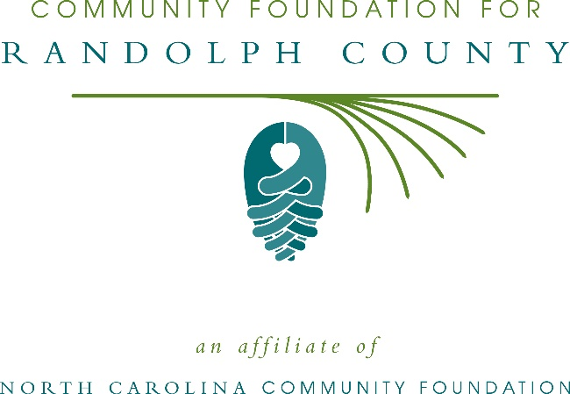
Community Foundation for Randolph County awards more than $5,000 in local grants
The board of advisors of the Community Foundation for Randolph County recently announced $5,770 in local grant awards from its community grantmaking fund, according to James Gouty, board president.
This year the board granted:
- $1,000 to Communities in Schools of Randolph County for an author visit
- $1,500 to Children’s Home Society of North Carolina, Inc. for Randolph County Family Recruitment
- $1,200 to Randolph County Partnership for Children for Reach Out & Read at Merce Family Practice
- $2,070 to Randolph-Asheboro YMCA for LIVESTRONG at the YMCA
Gouty thanked the community for its continued support of the Community Foundation for Randolph County. “We are proud to support these nonprofit programs that are so vital to the community,” he said. “We are grateful to the many generous individuals and organizations that have supported our work to inspire philanthropy across our county.”
For further information, contact NCCF Regional Director Dawn Neighbors at 910-292-4437 or dneighbors@nccommunityfoundation.org or visit the NCCF website at nccommunityfoundation.org.
About the Community Foundation for Randolph County
An affiliate of the North Carolina Community Foundation, the Community Foundation for Randolph County is a growing family of philanthropic funds, source of grants for local causes and partner for donors. The CFRC was founded in 1991 and is led by a local volunteer advisory board that helps build community assets through the creation of permanent endowments, makes grants and leverages leadership – all for the benefit of Randolph County.
The CFRC board advises the Community Foundation for Randolph County, the unrestricted community grantmaking fund, to support local needs. The competitive grants program is held on an annual basis. Advisory board members live and work in Randolph County, positioning them to strategically leverage resources, meet local needs and access opportunities. In addition to Gouty, board members include: Becky Greer (vice president), Lisa Hayworth (secretary), Kevin Franklin, Ray Hudson, Pam Hughes, Justin Kivett, Justin Luck, Jerry Moore and Darwin Smith.
The Community Foundation for Randolph County, through the NC Community Foundation, makes it easy to become a philanthropist, whatever your means or charitable goals. You can open an endowment for your favorite cause at any time – or contribute to an existing fund in any amount. Tax-deductible contributions, made payable to the Community Foundation for Randolph County, can be mailed to the North Carolina Community Foundation, 3737 Glenwood Ave. Suite 460, Raleigh, NC 27612. Contributions can also be made online at nccommunityfoundation.org.
About the North Carolina Community Foundation
The NCCF is the single statewide community foundation serving North Carolina and has administered more than $145 million in grants since its inception in 1988. With more than $270 million in assets, NCCF sustains 1,300 endowments established to provide long-term support of a broad range of community needs, nonprofit organizations institutions and scholarships. The NCCF partners with a network of affiliate foundations to provide local resource allocation and community assistance across the state. An important component of NCCF’s mission is to ensure that rural philanthropy has a voice at local, regional and national levels.
For more information, visit nccommunityfoundation.org.
News media contact
Louis Duke, NCCF Senior Communications Specialist
919-256-6922, lduke@nccommunityfoundation.org

