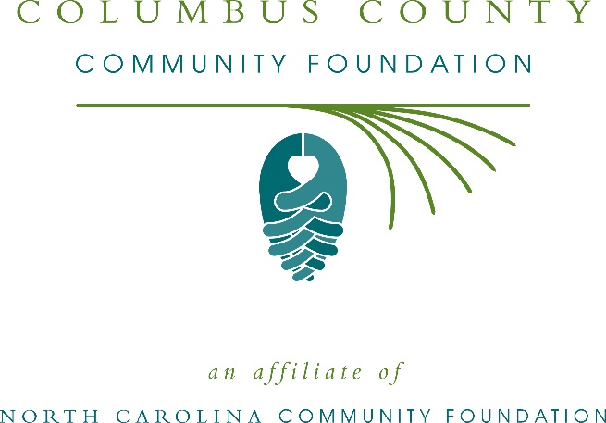
Columbus County Community Foundation awards more than $7,000 in local grants
The board of advisors of the Columbus County Community Foundation recently announced $7,328 in local grant awards from its community grantmaking fund, according to Becky High, board president.
This year the board granted:
- $1,000 to Prevent Blindness North Carolina for Star Pupils Columbus County
- $582 to Living Hope Pregnancy Support Services for Earn While You Learn Incentive Program
- $1,000 to Wilmington Family YMCA for Girls on the Run program expansion
- $1,000 to Lake Waccamaw Food Ministry for general operating support
- $1,000 to Columbus Baptist Association for Toy Store 2019
- $582 to Columbus County Sheriff’s Office for 2019 Project Lifesaver
- $582 to Matthew 25 at Tabor City, Inc. for support for families staying at the facility
- $1,000 to Columbus County Literacy Council for each One Teach One
- $582 to Columbus County DREAM Center, Inc. for Six Weeks of STEAM!
High thanked the community for its continued support of the Columbus County Community Foundation. “We are proud to support these nonprofit programs that are so vital to the community,” she said. “We are grateful to the many generous individuals and organizations that have supported our work to inspire philanthropy across our community.”
For further information, contact NCCF Regional Director Anne Sorhagen at 910-02-6727 or asorhagen@nccommunityfoundation.org or visit the NCCF website at nccommunityfoundation.org.
About the Columbus County Community Foundation
An affiliate of the North Carolina Community Foundation, the Columbus County Community Foundation is a growing family of philanthropic funds, source of grants for local causes and partner for donors. The CCCF was founded in 1999 and is led by a local volunteer advisory board that helps build community assets through the creation of permanent endowments, makes grants and leverages leadership – all for the benefit of Columbus County.
The CCCF board advises the Columbus County Community Foundation, the unrestricted community grantmaking fund, to support local needs. The competitive grants program is held on an annual basis. Advisory board members live and work in Columbus County, positioning them to strategically leverage resources, meet local needs and access opportunities. In addition to High, board members include: Henry Edmund (vice president), Liz McLean (secretary), Andy Wayne (treasurer), Amber Bellamy, Bill Gore, Gary Kramer, Lisa Richey, Terray Suggs, Kevin Williamson, Adam Wooten and Richard Wright.
The Columbus County Community Foundation, through the NC Community Foundation, makes it easy to become a philanthropist, whatever your means or charitable goals. You can open an endowment for your favorite cause at any time – or contribute to an existing fund in any amount. Tax-deductible contributions, made payable to the Columbus County Community Foundation, can be mailed to the North Carolina Community Foundation, 3737 Glenwood Ave. Suite 460, Raleigh, NC 27612. Contributions can also be made online at nccommunityfoundation.org.
About the North Carolina Community Foundation
The NCCF is the single statewide community foundation serving North Carolina and has administered more than $145 million in grants since its inception in 1988. With more than $270 million in assets, NCCF sustains 1,300 endowments established to provide long-term support of a broad range of community needs, nonprofit organizations institutions and scholarships. The NCCF partners with a network of affiliate foundations to provide local resource allocation and community assistance across the state. An important component of NCCF’s mission is to ensure that rural philanthropy has a voice at local, regional and national levels.
For more information, visit nccommunityfoundation.org.
News media contact
Louis Duke, NCCF Senior Communications Specialist
919-256-6922, lduke@nccommunityfoundation.org

