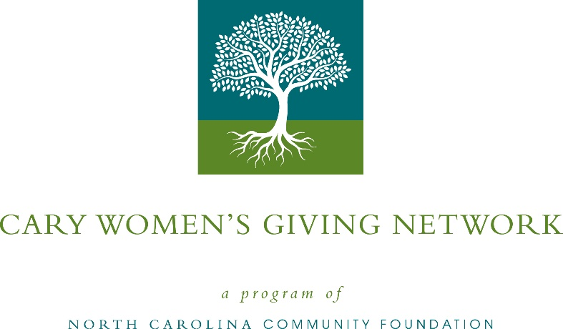
Cary’s Women’s Giving Network awards $14,000 in local grants
The board of advisors of the Cary Women’s Giving Network recently announced $14,000 in local grant awards, according to Sheila Ogle, board president.
The year the Network granted:
- $2,000 to The Carying Place, Inc. for life and fiscal management skills and transitional housing for homeless, working families with children
- $5,000 to StepUp Ministry for employment and life skills training for Cary Women and Children
- $7,000 to Wake Technical Community College Foundation for Fostering Bright Futures
Ogle thanked the community for its continued support of the Cary Women’s Giving Network. ““We are proud to support these nonprofit programs that are so vital to the community,” she said. “We are grateful to the many generous individuals and organizations that have supported our work to inspire philanthropy across our community.”
For further information, contact NCCF Grants Program Manager Christopher Fipps at 919-256-6923 or cfipps@nccommunityfoundation.org or visit the NCCF website at nccommunityfoundation.org.
About the Cary Women’s Giving Network
A program of the North Carolina Community Foundation, the Cary Women’s Giving Network is a giving circle that leverages the power of collective giving through a local network that supports the community in a purposeful way. The Network supports charitable organizations serving women, children and families in the Cary community. The Giving Network is designed to maximize women’s leadership in philanthropy by engaging and educating its membership and increasing charitable contributions.

About the North Carolina Community Foundation
The NCCF is the single statewide community foundation serving North Carolina and has administered more than $145 million in grants since its inception in 1988. With more than $270 million in assets, NCCF sustains 1,300 endowments established to provide long-term support of a broad range of community needs, nonprofit organizations institutions and scholarships. The NCCF partners with a network of affiliate foundations to provide local resource allocation and community assistance across the state. An important component of NCCF’s mission is to ensure that rural philanthropy has a voice at local, regional and national levels.
For more information, visit nccommunityfoundation.org.
News media contact
Louis Duke, NCCF Senior Communications Specialist
919-256-6922, lduke@nccommunityfoundation.org

