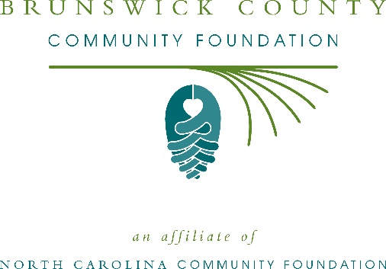
Brunswick County nonprofits awarded more than $56,000 in Hurricane Florence recovery grants from the North Carolina Community Foundation Disaster Relief Fund
The board of advisors of the Brunswick County Community Foundation recently awarded $56,250 in recovery grants from the North Carolina Community Foundation Disaster Relief Fund to support the long-term recovery of the local community from Hurricane Florence.
Grants received include:
- $12,000 to Brunswick Baptist Association to fund building materials and vendor services in the repair of homes damaged by Hurricane Florence in Brunswick County
- $7,000 to Brunswick Family Assistance Agency, Inc. (BFA) for long term recovery of repairing homes, supporting rapid rehousing for victims of Hurricane Florence in Brunswick County
- $7,250 to Brunswick Senior Resources, Inc. to provide funds for life alert systems for older adults and those with mobility impairments who were without a source of communication during Hurricane Florence in Brunswick County
- $6,000 to Matthew's Ministry to purchase food for children whose families were negatively impacted by Hurricane Florence in Brunswick County
- $12,000 to Trinity United Methodist Church to purchase washers and dryers for those impacted by Hurricane Florence in Brunswick County
- $12,000 to Wilmington Area Rebuilding Ministry, Inc. for rebuilding or repairing homes, and for providing appliances for those impacted by Hurricane Florence in Brunswick County
The grants were made from the NCCF Disaster Relief Fund’s initial grantmaking allocations to support long-term recovery and meet unmet needs from Hurricane Florence in Brunswick County.
“These grants are critical to the long-term recovery of Brunswick County from Hurricane Florence,” said Barbara Patten, BCCF board president. “The North Carolina Community Foundation Disaster Relief Fund is a pivotal resource to our local community thanks to the generosity of many donors who gave to help southeastern North Carolina.”
NCCF is keenly aware of how deeply Hurricane Florence impacted eastern North Carolina and devastated many communities in our state, according to Jennifer Tolle Whiteside, CEO and president. “The North Carolina Community Foundation has been in these communities for more than 30 years and will continue to be there supporting disaster recovery long after the TV cameras are gone,” she said. “We were grateful to see the outpouring of generosity that supported the NCCF Disaster Relief Fund and are honored to steward these funds to support long-term recovery efforts and meet unmet needs.”
About the Brunswick Community Foundation
An affiliate of the North Carolina Community Foundation, Brunswick County Community Foundation is a growing family of philanthropic funds, source of grants for local causes and partner for donors. The BCCF was founded in 1997 and is led by a local volunteer advisory board that helps build community assets through the creation of permanent endowments, makes grants and leverages leadership – all for the benefit of Brunswick County.
The BCCF board advises the Brunswick County Community Foundation, the unrestricted community grantmaking fund, to support local needs. The competitive grants program is held on an annual basis. Advisory board members live and work in Brunswick County, positioning them to strategically leverage resources, meet local needs and access opportunities. In addition to Patten, board members include: Julie Wolfe (secretary/treasurer), Cindy Cheatham, Mike Gildea, Donovan Hendricks, Heather Holbrook, Haylie Long, Franklin Rouse, Tom Simmons, Mary Walton and Justin Wolfe.
The Brunswick County Community Foundation, through the NC Community Foundation, makes it easy to become a philanthropist, whatever your means or charitable goals. You can open an endowment for your favorite cause at any time – or contribute to an existing fund in any amount. Tax-deductible contributions, made payable to the Brunswick County Community Foundation, can be mailed to the North Carolina Community Foundation, 3737 Glenwood Ave. Suite 460, Raleigh, NC 27612. Contributions can also be made online at nccommunityfoundation.org.
About the North Carolina Community Foundation
The NCCF is the single statewide community foundation serving North Carolina and has administered more than $145 million in grants since its inception in 1988. With more than $270 million in assets, NCCF sustains 1,300 endowments established to provide long-term support of a broad range of community needs, nonprofit organizations institutions and scholarships. The NCCF partners with a network of affiliate foundations to provide local resource allocation and community assistance across the state. An important component of NCCF’s mission is to ensure that rural philanthropy has a voice at local, regional and national levels.
For more information, visit nccommunityfoundation.org.
News media contact
Louis Duke, NCCF Senior Communications Specialist
919-256-6922, lduke@nccommunityfoundation.org

