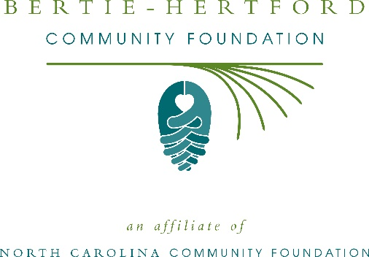
Bertie-Hertford Community Foundation and Women’s Fund award more than $7,000 in local grants
The Bertie-Hertford Community Foundation and Bertie-Hertford Women’s Fund recently announced $7,360 in local grant awards, according to John Tayloe, board president of the BHCF and Penny Rose, president of the Women’s Fund.
This year the BHCF board granted:
- $760 to the MAP Community Development Corporation for the Level Up Summer Enrichment Program
- $1,000 to Good Shepherd Food Pantry of Bertie County, NC, Inc. for fresh fruit
- $1,000 to the Ahoskie Food Pantry for general operational support
- $____ to Toni Darden, Samantha Farrow and Zaria Hunter for the MC Ashe Scholarship
This year the Bertie-Hertford Women’s Fund granted:
- $2,100 to NC Cooperative Extension for the Learn to Swim program
- $2,500 to Roanoke Chowan Christian Women’s Job Corps, Inc. for the A Hand Up Not a Hand Out Program
Tayloe thanked the community for its continued support of the Bertie-Hertford Community Foundation. “We are proud to support these nonprofit programs that are so vital to the community,” he said.
Rose also thanks the community for its support. “We are grateful to the many generous individuals and organizations that have supported our work to inspire philanthropy across our community,” she said.
For further information, contact NCCF Regional Director Natalie Jenkins Peel at 252-562-9824 or npeel@nccommunityfoundation.org or visit the NCCF website at nccommunityfoundation.org.
About the Bertie-Hertford Community Foundation
An affiliate of the North Carolina Community Foundation, the Bertie-Hertford Community Foundation is a growing family of philanthropic funds, source of grants for local causes and partner for donors. The BHCF was founded in 1999 and is led by a local volunteer advisory board that helps build community assets through the creation of permanent endowments, makes grants and leverages leadership – all for the benefit of Bertie and Hertford counties.
The BHCF board advises the Bertie-Hertford Community Fund, the unrestricted community grantmaking fund, to support local needs. The competitive grants program is held on an annual basis. Advisory board members live and work in Bertie and Hertford counties, positioning them to strategically leverage resources, meet local needs and access opportunities. In addition to Tayloe, board members include: Penny Rose (vice president), Lindsay Vaughan (secretary/treasurer), Laura Beasley, Gail Carter, Austine Evans, Anna Pierce, Karen Ray, Marti Tyler, Cathy Wilson and Wayland L. Jenkins.
The Bertie-Hertford Community Foundation, through the NC Community Foundation, makes it easy to become a philanthropist, whatever your means or charitable goals. You can open an endowment for your favorite cause at any time – or contribute to an existing fund in any amount. Tax-deductible contributions, made payable to the Bertie-Hertford Community Foundation, can be mailed to the North Carolina Community Foundation, 3737 Glenwood Ave. Suite 460, Raleigh, NC 27612. Contributions can also be made online at nccommunityfoundation.org.
About the Bertie-Hertford Women’s Fund
A program of the North Carolina Community Foundation, the Bertie-Hertford Women’s Fund is a giving circle that leverages the power of collective giving through a local network that supports the community in a purposeful way. The Fund supports charitable organizations serving women, children and families in Bertie and Hertford counties. The Women’s Fund is designed to maximize women’s leadership in philanthropy by engaging and educating its membership, increasing charitable contributions and focusing on initiatives that address the areas of health, education and human services.
About the North Carolina Community Foundation
The NCCF is the single statewide community foundation serving North Carolina and has administered more than $145 million in grants since its inception in 1988. With more than $270 million in assets, NCCF sustains 1,300 endowments established to provide long-term support of a broad range of community needs, nonprofit organizations institutions and scholarships. The NCCF partners with a network of affiliate foundations to provide local resource allocation and community assistance across the state. An important component of NCCF’s mission is to ensure that rural philanthropy has a voice at local, regional and national levels.
For more information, visit nccommunityfoundation.org.
Cutline for photo
Members of the board of advisors of the Bertie-Hertford Community Foundation with local grants and scholarships recipients at the annual grants awards ceremony.
News media contact
Louis Duke, NCCF Senior Communications Specialist
919-256-6922, lduke@nccommunityfoundation.org

