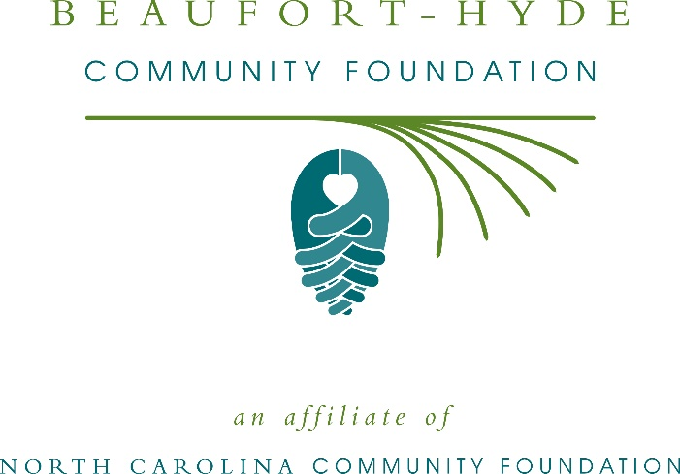
Beaufort-Hyde Community Foundation awards more than $24,000 in local grants
The board of advisors of the Beaufort-Hyde Community Foundation recently announced $24,370 in local grant awards from its community grantmaking fund and the Lights of Love Endowment, according to Stuart O’Neal, board president.
This year the board granted:
- $910 to the Albemarle Commission Senior Nutrition Program for Hyde County Meals on Wheels
- $910 to Daughters of Worth for their Beaufort County programming
- $22,550 to Vidant Beaufort Hospital for the support of various supplemental programs
  - $750 to the Behavioral Health Department for a sensory room
  - $2,972 to the Intensive Care Unit for blanket warmers
  - $6,145 to the Physical Therapy Department for a mobile mat
  - $600 to the Community Health Improvement Department for CardioCheck equipment
  - $2,972 to the 3 East Medical Unit for blanket warmers
  - $2,397 to Patient Access Services/ Emergency Department for a cell phone charging station
  - $6,713 to the Nursing Administration Department for Vocera
O’Neal thanked the community for its continued support of the Beaufort-Hyde Community Foundation. “We are proud to support these nonprofit programs that are so vital to the community,” he said. “We are grateful to the many generous individuals and organizations that have supported our work to inspire philanthropy across our community.”
Phil Holloman, Lights of Love advisory committee board member, expressed the importance of the grants awarded. “Living in this community helps to understand just how impactful these grants are on a local level,” he said.
For further information, contact NCCF Regional Director Natalie Jenkins Peel at 252-562-9824 or npeel@nccommunityfoundation.org or visit the NCCF website at nccommunityfoundation.org.
About the Beaufort-Hyde Community Foundation
An affiliate of the North Carolina Community Foundation, the Beaufort-Hyde Community Foundation is a growing family of philanthropic funds, source of grants for local causes and partner for donors. The BHCF was founded in 2001 and is led by a local volunteer advisory board that helps build community assets through the creation of permanent endowments, makes grants and leverages leadership – all for the benefit of Beaufort and Hyde counties.
The BHCF board advises the Beaufort-Hyde Community Fund, the unrestricted community grantmaking fund, to support local needs. The competitive grants program is held on an annual basis. Advisory board members live and work in Beaufort or Hyde counties, positioning them to strategically leverage resources, meet local needs and access opportunities. In addition to O’Neal, board members include: Bill Rich (vice president), Buffy Johnson (secretary/treasurer), Read Allen, Lee Brimmage, Charles Edwards, March Morgan, Bethany Pugh, George Taylor and Beth Wilder.
The Beaufort-Hyde Community Foundation, through the NC Community Foundation, makes it easy to become a philanthropist, whatever your means or charitable goals. You can open an endowment for your favorite cause at any time – or contribute to an existing fund in any amount. Tax-deductible contributions, made payable to the Beaufort-Hyde Community Foundation, can be mailed to the North Carolina Community Foundation, 3737 Glenwood Ave. Suite 460, Raleigh, NC 27612. Contributions can also be made online at nccommunityfoundation.org.
About the North Carolina Community Foundation
The NCCF is the single statewide community foundation serving North Carolina and has administered more than $145 million in grants since its inception in 1988. With more than $270 million in assets, NCCF sustains 1,300 endowments established to provide long-term support of a broad range of community needs, nonprofit organizations institutions and scholarships. The NCCF partners with a network of affiliate foundations to provide local resource allocation and community assistance across the state. An important component of NCCF’s mission is to ensure that rural philanthropy has a voice at local, regional and national levels.
For more information, visit nccommunityfoundation.org.
Cutline for photo:
Members of the board of advisors of Beaufort-Hyde Community Foundation with local fundholders, fund advisors, and grant recipients at the annual grants ceremony.
Pictured (Front row left to right): Pam Shadle, Vidant Beaufort Hospital; Chris Tkach, Jimmy Oakley, Frank Belote, Alma Friedman, and Phil Holloman (Lights of Love Fund Advisors); Mary Esther Baker, Fundholder.
Second row (left to right): Stuart O’Neal, BHCF President; Beth Wilder, BHCF Board Member; Liz Liles, Daughters of Worth; Debra Torrence, Pamlico of the Arts; Laura Alvarico, Albemarle Commission Senior Nutrition Program; Natalie Jenkins Peel, North Carolina Community Foundation; Amy and Paul Sasnett, The Reid Sasnett Memorial Scholarship; Bill Rich, BHCF Vice President.
Back row (left to right): William Taylor, BHCF Board Member; Wilson Simmons, North Carolina Community Foundation; Johnny Bratton, North Carolina Community Foundation; Marcy Morgan, BHCF Board Member and Pungo Christian Academy Fundholder.

News media contact
Louis Duke, NCCF Senior Communications Specialist
919-256-6922, lduke@nccommunityfoundation.org

