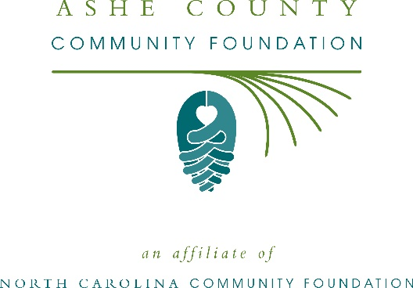
Ashe County Community Foundation awards more than $5,000 in local grants
The board advisors of the Ashe County Community Foundation recently announced $5,390 in local grant awards from its community advancement fund and the Daniel Lee “Dan” Eldreth Memorial Endowment, according to Christina Wagoner, board president.
This year the board granted:
- $500 to Ashe Assisted Living & Memory Care for Rest & Renewal Retreats
- $500 to Prevent Blindness North Carolina for Star Pupils Ashe County
- $500 to Wilkes Community College- Ashe Family Literacy for Ashe Family Literacy Childcare
- $500 to Ashe County Partnership for Children for Planting the Seeds to Read
- $500 to Ashe County Arts Council for African-American Heroes
- $500 Communities in Schools of Northwest North Carolina for books for teachers at ACMS
- $500 to Second Harvest Food Bank of Northwest NC for weekend backpacks for seniors
- $890 to Appalachian State University for Appalachian Senior Programs
- $500 to Appalachian State University for support for Ashe County families
- $500 to Ashe County Public Library for Ashe County Veteran History Project
Wagoner thanked the community for its continued support of the Ashe County Community Foundation. “We are proud to support these nonprofit programs that are so vital to the community,” she said. “We are grateful to the many generous individuals and organizations that have supported our work to inspire philanthropy across our community.”
For further information, contact NCCF Regional Director Colby Martin at 828-358-0030 or cmartin@nccommunityfoundation.org or visit the NCCF website at nccommunityfoundation.org.
About the Ashe County Community Foundation
An affiliate of the North Carolina Community Foundation, the Ashe County Community Foundation is a growing family of philanthropic funds, source of grants for local causes and partner for donors. The ACCF was founded in 1995 and is led by a local volunteer advisory board that helps build community assets through the creation of permanent endowments, makes grants and leverages leadership – all for the benefit of Ashe County.
The ACCF board advises the Ashe County Community Foundation, the unrestricted community grantmaking fund, to support local needs. The competitive grants program is held on an annual basis. Advisory board members live and work in Ashe County, positioning them to strategically leverage resources, meet local needs and access opportunities. In addition to Wagoner, board members include: Karen Powell (grants chair), Jacquelyne Isner (secretary), Jan Hershner, Elaine Graham, Suzanne Moore and Jason Sutherland.
The Ashe County Community Foundation, through the NC Community Foundation, makes it easy to become a philanthropist, whatever your means or charitable goals. You can open an endowment for your favorite cause at any time – or contribute to an existing fund in any amount. Tax-deductible contributions, made payable to the Ashe County Community Foundation, can be mailed to the North Carolina Community Foundation, 3737 Glenwood Ave. Suite 460, Raleigh, NC 27612. Contributions can also be made online at nccommunityfoundation.org.
About the North Carolina Community Foundation
The NCCF is the single statewide community foundation serving North Carolina and has administered more than $145 million in grants since its inception in 1988. With more than $270 million in assets, NCCF sustains 1,300 endowments established to provide long-term support of a broad range of community needs, nonprofit organizations institutions and scholarships. The NCCF partners with a network of affiliate foundations to provide local resource allocation and community assistance across the state. An important component of NCCF’s mission is to ensure that rural philanthropy has a voice at local, regional and national levels.
For more information, visit nccommunityfoundation.org.
News media contact
Louis Duke, NCCF Senior Communications Specialist
919-256-6922, lduke@nccommunityfoundation.org

