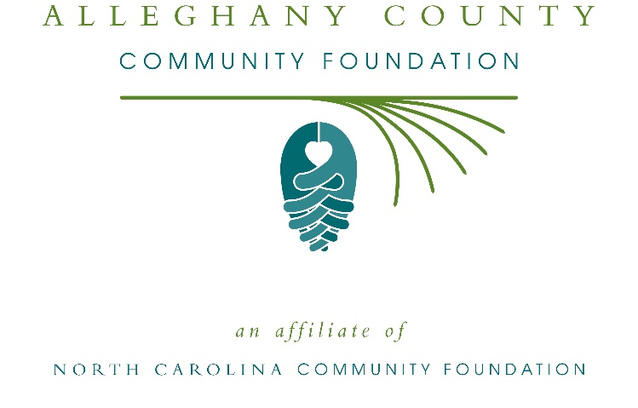
Alleghany County Community Foundation awards more than $13,000 in local grants
The board of advisors of the Alleghany County Community Foundation recently announced $13,020 in local grant awards from its community grantmaking fund, according to Greg Bare, board president.
This year the board granted:
- $1,000 to Alleghany County Library for 2019-2020 Stretch Your Body and Your Mind
- $1,000 to Alleghany Partnership for Children for community events
- $582 to Piney Creek School for World Changers- Using the UN’s Sustainable Development Goals to Make a Difference in the World
- $1,525 to Communities in Schools of Northwest North Carolina for Sparta School Playground
- $2,000 to Blue Ridge Developmental Day for programming
- $1,500 to Second Harvest Food Bank of Northwest NC for Partner Agency Support-Solid Rock Food Closet
- $500 to Sparta Revitalization Committee for Sparta Streetscape Enhancement
- $913 to Appalachian State University for Appalachian Senior Programs
- $500 to Alleghany Arts Council for Blue Ridge Read 2019
- $2,000 to Alleghany Writers for critical and creative visual thinking
- $1,500 to Alleghany Wellness Center, Inc. for their operations
Bare thanked the community for its continued support of the Alleghany County Community Foundation. “We are proud to support these nonprofit programs that are so vital to the community,” he said. “We are grateful to the many generous individuals and organizations that have supported our work to inspire philanthropy across our community.”
For further information, contact NCCF Regional Director Colby Martin at 828-358-0030 or cmartin@nccommunityfoundation.org or visit the NCCF website at nccommunityfoundation.org.

About the Alleghany County Community Foundation
An affiliate of the North Carolina Community Foundation, the Alleghany County Community Foundation is a growing family of philanthropic funds, source of grants for local causes and partner for donors. The ACCF was founded in 1993 and is led by a local volunteer advisory board that helps build community assets through the creation of permanent endowments, makes grants and leverages leadership – all for the benefit of Alleghany County.
The ACCF board advises the Alleghany County Community Foundation, the unrestricted community grantmaking fund, to support local needs. The competitive grants program is held on an annual basis. Advisory board members live and work in Alleghany County, positioning them to strategically leverage resources, meet local needs and access opportunities. In addition to Bare, board members include: Ashley Flowers (vice president), Pratt Davis (secretary), Kay Choplin (treasurer), Debbie Bare, Zach Barricklow, Michael Beres, Edward Choplin, Molly DuBose, Terry Edwards, Sandy League, Brett Liverman and Steve Mason.
The Alleghany County Community Foundation, through the NC Community Foundation, makes it easy to become a philanthropist, whatever your means or charitable goals. You can open an endowment for your favorite cause at any time – or contribute to an existing fund in any amount. Tax-deductible contributions, made payable to the Alleghany County Community Foundation, can be mailed to the North Carolina Community Foundation, 3737 Glenwood Ave. Suite 460, Raleigh, NC 27612. Contributions can also be made online at nccommunityfoundation.org.
About the North Carolina Community Foundation
The NCCF is the single statewide community foundation serving North Carolina and has administered more than $145 million in grants since its inception in 1988. With more than $270 million in assets, NCCF sustains 1,300 endowments established to provide long-term support of a broad range of community needs, nonprofit organizations institutions and scholarships. The NCCF partners with a network of affiliate foundations to provide local resource allocation and community assistance across the state. An important component of NCCF’s mission is to ensure that rural philanthropy has a voice at local, regional and national levels.
For more information, visit nccommunityfoundation.org.
Cutline for photo
Ashley Flowers (left) grants chair of the Alleghany Community Foundation presents a check to representatives of Communities in Schools of Northwest North Carolina to aid in the playground renovation at Sparta Elementary School.
News media contact
Louis Duke, NCCF Senior Communications Specialist
919-256-6922, lduke@nccommunityfoundation.org

