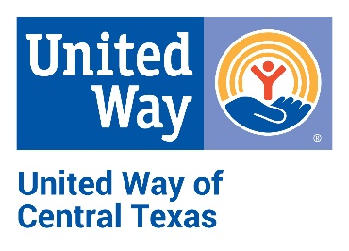
United Way of Central Texas
Campaign Report Envelope
4 N 3rd St | P.O. Box 1312 | Temple, TX 76503
254-778-8616 | www.UWCT.org

Firm Name_____________________________________________ Date___________
Employee Campaign Coordinator (ECC)______________________________________
Address_________________________________________ ECC Phone_____________
City______________________________________________ State_____ Zip________

This is a Partial Report Final Report (campaign complete)
Please do not include results from any previous report

Payroll deductions begin in January? Yes No If not, when?_____________
Number of Payroll Periods__________
Payroll deduction funds will be sent to United Way office:
Monthly Quarterly Weekly

- Please be sure this report reflects only Pledge Authorizations and Payments enclosed in this envelope. Check the Partial Report box if additional reports are to be made.
Total Number of Donors__________
Total Number of Employees_______
REQUIREDD
- Complete summary of this report on Lines 1 through 6.
Line No. |  | Number of Gifts | Total Amount Given
1 | Payroll Deductions  (Enclose employee listing sheet. Individual payroll cards must be retained by the payroll department.)
2 | Direct Billing  (Enclose individual cards and listing sheet. Signatures and addresses are required.)
3 | Fully Paid Gifts  (Enclose cash, checks, all cards, and listing sheet. Signatures are required.)
4 | Total Employee Gifts  (Sum of Lines 1, 2, & 3)
5 | Corporate Gift  (Enclose card. Signature required.)
6 | Grand Total All Gifts  (Sum of Lines 4 & 5)

