TOWN OF WENDELL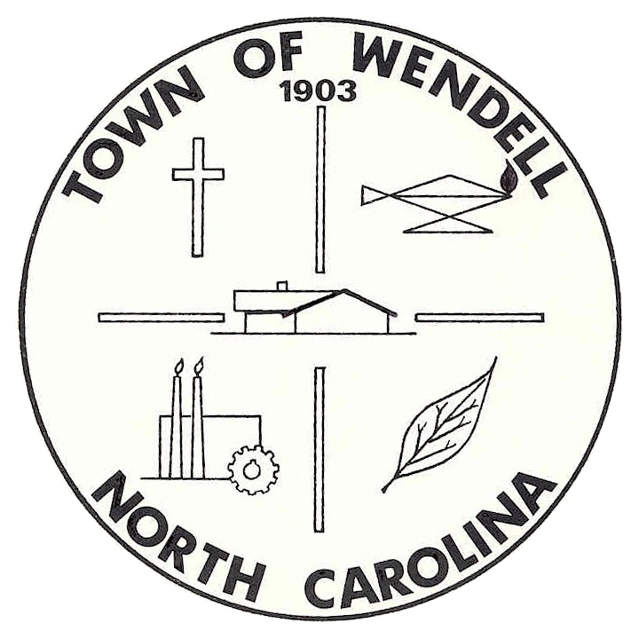NORTH CAROLINA

ECONOMIC DEVELOPMENT COMMITTEE
MEETING

AGENDA
Downtown / Town Branding Workgroup

Wednesday, February 12, 2014 Wendell Community Center - Conference Room
1:00 PM – 2:30 PM 601 W. Third Street, Wendell, North Carolina

- Meeting Called to Order
A quorum of the Economic Development Committee is required before taking official action.

- Welcome

- Public Comments:
  - Individuals interested in speaking during the public comments time will need to sign up prior to the beginning of the meeting. The signup period will begin thirty (30) minutes prior to the beginning of the meeting and conclude at the beginning of the meeting.
  - Each individual may be limited to a time of three (3) minutes in which to express his or her concerns.
  - Individuals making public comments are expected to be courteous to the Committee.

- Draft Minutes:
  - October 23, 2013 – Downtown Workgroup Meeting
  - December 18, 2013 – Downtown Workgroup Meeting
  - January 8, 2014 – Downtown Workgroup Meeting

- Downtown Brochure – Review/Purpose/Distribution Policy
  - Copies to be provided at meeting. Accessible online at http://www.townofwendell.com/discover/downtown-wendell

- Update on Property Database Recruitment Efforts

- Discussion on Modified Electronic Message Board Sign Design & Sign Locations

- Committee Members Comments

- Adjourn to Next Regularly Scheduled Meeting

