TOWN OF WENDELL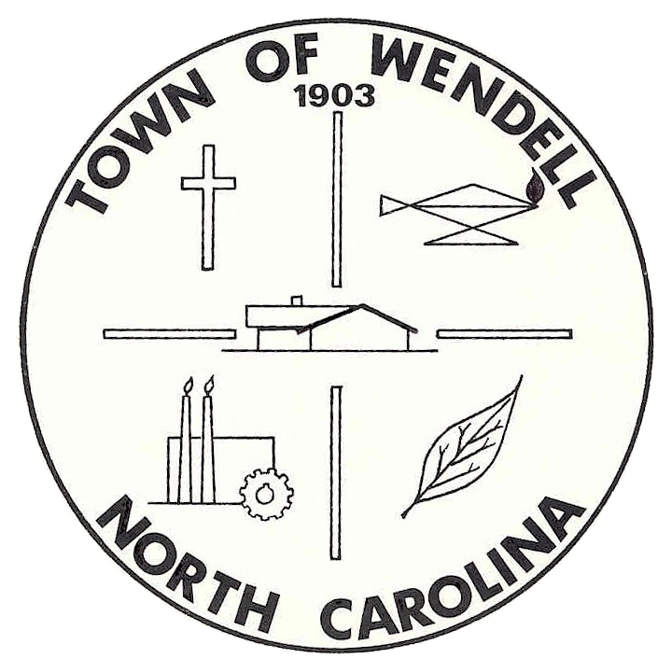NORTH CAROLINA

ECONOMIC DEVELOPMENT COMMITTEE
MEETING

AGENDA
Corporate Development / Industry Workgroup

Wednesday, February 12, 2014 Wendell Community Center - Conference Room
10:00 A.M – 11:30 A.M 601 W. Third Street, Wendell, North Carolina

- Meeting Called to Order
A quorum of the Economic Development Committee is required before taking official action.

- Welcome

- Public Comments:
  - Individuals interested in speaking during the public comments time will need to sign up prior to the beginning of the meeting. The signup period will begin thirty (30) minutes prior to the beginning of the meeting and conclude at the beginning of the meeting.
  - Each individual may be limited to a time of three (3) minutes in which to express his or her concerns.
  - Individuals making public comments are expected to be courteous to the Committee.

- Draft Minutes:
  - January 8, 2014 – Corporate Development Workgroup Meeting

- Review and discussion of the following items:
  - Subdivision Status Update
  - Status of Workgroup Objectives/Goals moving forward
    - Review of the Economic Development Strategic Plan

- Committee Members Comments

- Adjourn to Next Regularly Scheduled Meeting

