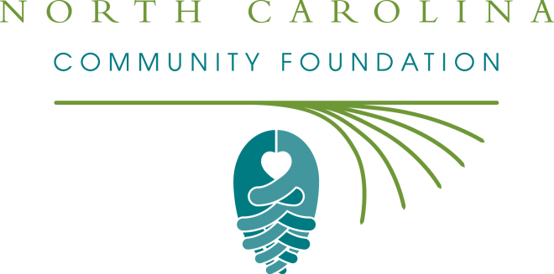

Frances Abbot Burton Powers Endowment Fund
2015 Grant Cycle

The Frances Abbot Burton Powers Endowment Fund will make grant funds available for government entities and nonprofit organizations that have a physical location in and benefit the Town of Henderson.

The 2015 grant application period will be open Friday, June 5 through Tuesday, June 30. All organizations will be notified by the end of July. Grants will typically range from $5,000 to $15,000. A board of advisors will determine grant awards.

Please submit all applications electronically to :
Katie B. Crumpler
Northern Piedmont Regional Associate, NC Community Foundation
kcrumpler@nccommunityfoundation.org
919.256.6914
Feel free to contact Katie with questions!

Frances Abbot Burton Powers Endowment Fund
2015 Grant Application

ORGANIZATION NAME EMPLOYER IDENTIFICATION NUMBER (EIN xx-xxxxxxx)

CONTACT PERSON (If not the Executive Officer of the organization, please specify that person as well.)

ADDRESS

PHONE NUMBER WEBSITE

EMAIL ADDRESS

Please answer each question within the character limit specified.

Amount Requested - grants will range from $5,000 to $15,000.

Brief Request Summary

Program/Project Begin Date
General Operating Support applicants should include the begin date of the organization's fiscal year.

Program/Project End Date
General Operating Support applicants should include the end date of the organization's fiscal year.

Total Program/Project Budget
If applying for General Operating Support, please enter your organization's total operating budget.

Community Need
Describe the existing community need that will be addressed if this request is funded.
Character Limit: 3000

Activities/Operations
If applying for a Program/Project, please outline the specific activities and timetable. If applying for General Operating Support, please describe the organization's general operations, including any significant events.
Character Limit: 3000

Staff, Volunteers, Partners
Who are the key staff or volunteers responsible, and what are their qualifications? List any collaborating organizations.
Character Limit: 3000

Goals and Objectives
What are the goals and measurable objectives that could be met with this funding support?
Character Limit: 3000

Evaluation Procedures
How will you measure success? Describe the evaluation process.
Character Limit: 3000

Organization Description
Select one of the following options to describe your organization:
- 501c3 public charity
- Government Entity (includes public schools)
- Religious Organization

Organization's Operating Budget
How much is your organization’s total operating budget? Please select only one of the following choices:
- Less than $50,000
- $100,000 or less
- $250,000 or less
- $500,000 or less
- More than $500,000

ATTACHED: Organizational Budget
All applicants must use the template provided (attached) to submit organizational budget information. No other documents will be accepted. Please download the template to your computer and save it according to the instructions on the template. Once completed, attach the document to the email you are submitting with this grant application.
ONLY EXCEPTION: Public schools and Government agencies are not required to submit an organizational budget in this format. Instead, please provide the contact information of a person who can answer questions regarding your organization's budget.

ATTACHED: Program/Project Budget
All applicants must use the template provided (attached) to submit budget information specific to this program/project. No other documents will be accepted. Please download the template to your computer and save it according to the instructions on the template. Once completed, attach the document to the email you are submitting with this grant application.
If applying for general operating support, do not include this program/project budget.

Current Board Members
Add current board members for your organization by entering their full name, board title, organization, and city of residency. Alternatively, you may attach another file that includes this information.

Board Member Contribution
What percentage of your board members have made a financial contribution to your organization in the last twelve (12) months? Please select only one of the following choices:

- 100%
- About 75%
- About 50%
- About 25%
- 0%

Request Submission Terms and Agreement
If you are ready to send your application to NCCF, you must first complete the legal section below, electronically sign, and then email to Katie Crumpler – kcrumpler@nccommunityfoundation.org.
Note – by checking/highlighting the boxes, you are agreeing to the terms specified.

- This organization does not discriminate.
This organization does not discriminate on the basis of race, color, religion, age, gender, national origin, or disability (in accordance with applicable federal laws).

- If awarded, grantee with comply with grant purpose and reporting requirements.
Any funds received for this proposal will be used for the stated charitable purpose and in accordance with the grant terms and conditions enclosed in the award letter, including completion of required reports by their deadlines.

- If awarded, grantee will follow NCCF's acknowledgement and publicity guidelines.
We will acknowledge any grant received in accordance with the terms outlined in the grant award letter, and the NCCF may publicize this project or program in all publications, including web-based communications, should the proposal be funded.

NCCF may share this proposal. (Participation Not Mandatory)
Should this proposal not be funded by this NCCF grants program, the organization authorizes NCCF to share this proposal in its entirety with other potential funding sources at its discretion.
- Yes
- No

Digital Signature
By typing my name in the following space, I certify that I am an authorized representative of the charitable organization named in this application. I further certify that this application is submitted with the full knowledge and consent of the organization's Board of Directors or other governing body.

