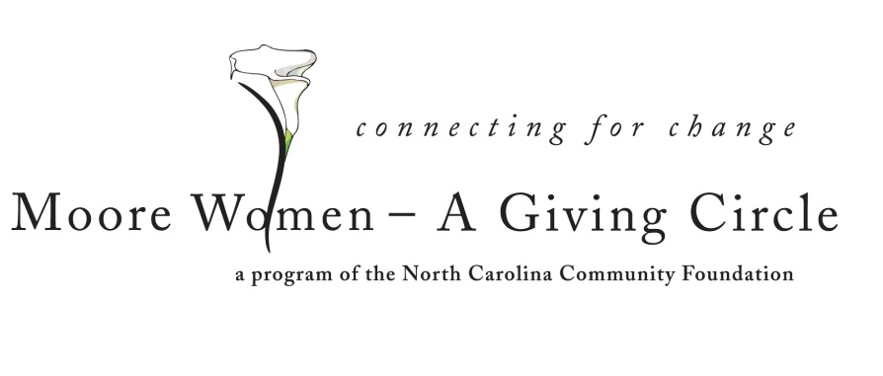
FOR IMMEDIATE RELEASE – 06/22/15
Moore Women’s Giving Circle accepting grant applications
Moore Women – A Giving Circle is currently accepting grant requests for community projects, according to Susie Buchanan, co-chair.
Funds are available for nonprofit organizations that serve the needs of women and/or children in Moore County.
Applications are available online only beginning June 26. Visit nccommunityfoundation.org and go to Women’s Giving/Moore Women for information about applying online. The deadline for submitting applications is noon Aug. 11.
The Moore Women’s Giving Circle is an affiliate of the North Carolina Community Foundation. The giving fund was established to help support local charitable needs through annual grants. In addition to Buchanan, members are: Elizabeth Cox (co-chair), Caroline Eddy, Ellen Airs, Cos Barnes, Cele Bryant, Gail Clark, Jane Clark, Anita Emery, Penny Enroth, Amie Fraley, Tina Ganis, Penny Junk, Peggy Miller, Sandi Mardigian, Gwen Murray, Clare Ruggles, Teresa VanCamp, Madge Wilkins and Caroline Young.
For further information, contact any member; the NCCF Regional Associate Mary Anne Howard at 919-256-6924 or visit the NCCF website at www.nccommunityfoundation.org.
About the North Carolina Community Foundation
The NCCF is the single statewide community foundation serving North Carolina and has made $89 million in grants since its inception in 1988. With more than $191 million in assets, NCCF sustains 1,200 endowments established to provide long-term support of a broad range of community needs, nonprofit organizations, institutions and scholarships. The NCCF partners with 60 affiliate foundations to provide local resource allocation and community assistance in 67 counties across the state. An important component of NCCF’s mission is to ensure that rural philanthropy has a voice at local, regional and national levels.
For more information, visit nccommunityfoundation.org and Facebook or follow LinkedIn and Twitter @NCCF.
###
News media contacts:
Mary Anne Howard, NCCF Regional Associate
919-256-6924; mhoward@nccommunityfoundation.org
Noel McLaughlin, NCCF Director, Marketing and Communications
919-256-6901; nmclaughlin@nccommunityfoundation.org

