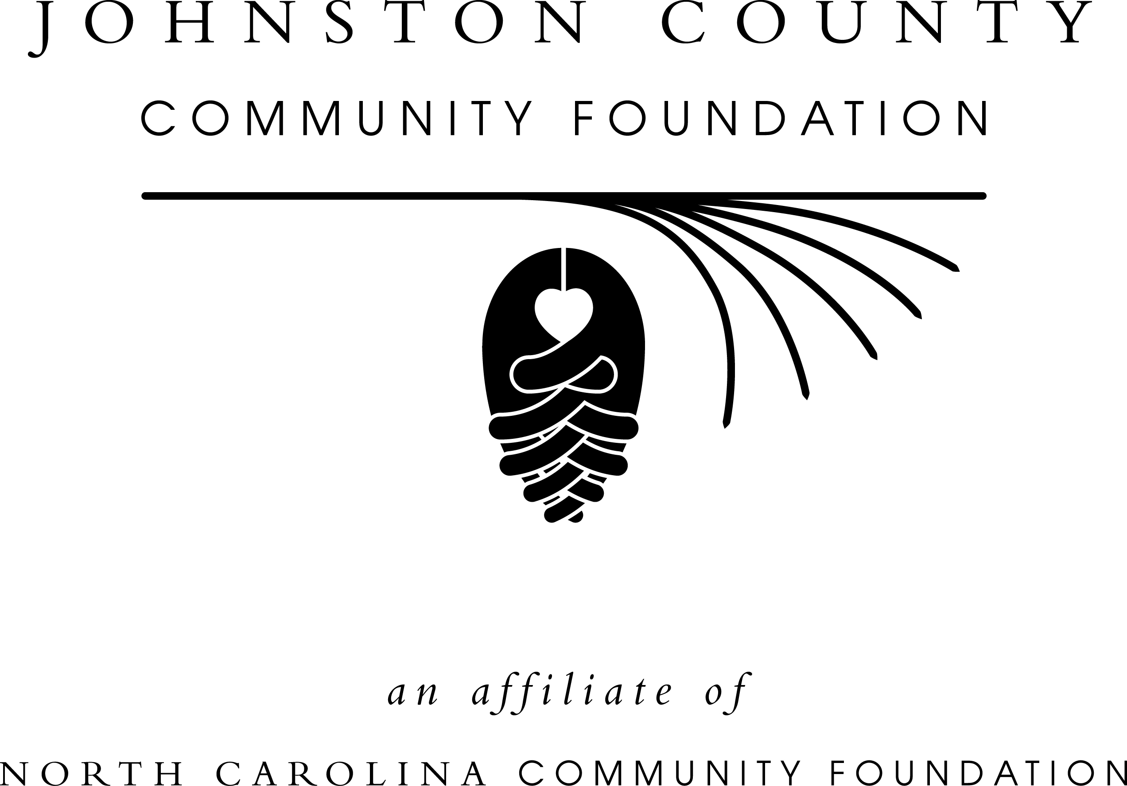

Frances Finch Hobart Award for Voluntary Community Service

The Johnston County Community Foundation is pleased to announce the 2015 selections process for the Frances Finch Hobart Award for Voluntary Community Service. This award was established in 2006 to recognize persons for their commitment to voluntary community service.

The award is presented annually to an individual from Johnston County who has demonstrated a commitment to serving his/her community resulting in a stronger community in which to live, work, and enjoy life.

The recipient of this award shall possess the ability to help others solve social problems by giving of his/her time, talent and energy. This person shall demonstrate an actual accomplishment achieved through the work of volunteering, that through his/her volunteering a community need has been met. The person shall manifest the ability to mobilize other volunteers and display a willingness for on-going involvement. The recipient shall demonstrate vision, vitality, determination, selflessness, generosity, and a full, caring heart.

This year’s recipient will be publicly recognized during the 2015 Johnston County Community Foundation Awards event this spring and will be asked to select a local non-profit to receive a $750.00 grant from the Frances Finch Hobart Award for Voluntary Community Service Fund.

Instructions for Submitting an Application

- Complete the Nomination Form

- Attach a listing of all the agencies/organizations the nominees has volunteered and the dates of service

- Return completed nomination packet by April 21, 2015.

- Mail to:
Johnston County Community Foundation
PO Box 1377
Smithfield, NC 27577
ATTN: Bill Galloway

Frances Finch Hobart Award for Voluntary Community Service
2015 Nomination Application

Nominee’s Personal Information (PLEASE PRINT)
Nominee’s Name
Mailing Address
City |  |  | State |  | Zip
Phone (h) | Phone (w) |  |  | Phone (c)
Is the individual aware of this nomination?  YES NO |  | E-mail

Nominator’s Personal Information (PLEASE PRINT)
Nominator’s Name
Mailing Address

City |  |  | State | Zip
Phone (h) | Phone (w) | Phone (c) | E-mail
Signature of Nominator

Using a 12-point font size, reasonable margins, and no more than 2 pages, please answer the following.

- Describe the nominee’s volunteer involvement; naming the organization(s) and describing the type of volunteer service.

- Describe the impact this nominee has had on the organization(s) in which he/she has volunteered.

- Frances Finch Hobart, the woman for whom this award is named, demonstrates vision, vitality, determination, selflessness, generosity and a full, caring heart. How does this nominee demonstrate these same attributes?

