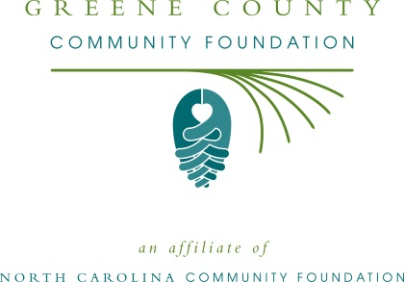
FOR IMMEDIATE RELEASE – 06/24/2015
Greene County Community Foundation accepting grant applications
The board of advisors of the Greene County Community Foundation is currently accepting grant requests for community projects funded from its community fund, according to Christie Mozingo, board president.
Funds are available for nonprofit organizations that serve general charitable needs in Greene County.
Applications are available online only beginning July 17. Visit nccommunityfoundation.org for information about applying online. The deadline for submitting applications is noon Sep. 1.
“These grants are important to our community and our quality of life,” Mozingo said. “Critical programs would not be possible without the generosity of many individuals and organizations that have supported Carteret County’s community fund.”
The Greene County Community Foundation is an affiliate of the North Carolina Community Foundation. The community fund was established to help support local charitable needs through annual grants.
Tax-deductible contributions can be made to the Greene County Community Foundation. Contributions should be made payable to the Greene County Community Fund and mailed to the North Carolina Community Foundation, Landmark Center, 4601 Six Forks Road, Suite 524, Raleigh, NC 27609. Contributions can also be made online at www.nccommunityfoundation.org.
In addition to Mozingo, board members are: Micheal Rhodes (vice-president), Dr. Faith F. Bynum (secretary-treasurer), Dora Pasour (immediate past president), Erika Churchill, Judy W. Davenport, Laquita Davis, Randy Davis, Arthur Ray Holloman, Beth M. Moye, Rebecca Pate, Jody C. Tyson and Nina Paul Vinson.
For further information, contact any board member; the NCCF Regional Associate Kim Ball at 252-288-5706 or visit the NCCF website at www.nccommunityfoundation.org.
About the North Carolina Community Foundation
The NCCF is the single statewide community foundation serving North Carolina and has made $89 million in grants since its inception in 1988. With more than $191 million in assets, NCCF sustains 1,200 endowments established to provide long-term support of a broad range of community needs, nonprofit organizations, institutions and scholarships. The NCCF partners with 60 affiliate foundations to provide local resource allocation and community assistance in 67 counties across the state. An important component of NCCF’s mission is to ensure that rural philanthropy has a voice at local, regional and national levels.
For more information, visit nccommunityfoundation.org and Facebook or follow on LinkedIn and Twitter @NCCF.
###
News Media Contacts:
Kim Smith Ball, NCCF Regional Associate
252-288-5706; kball@nccommunityfoundation.org

