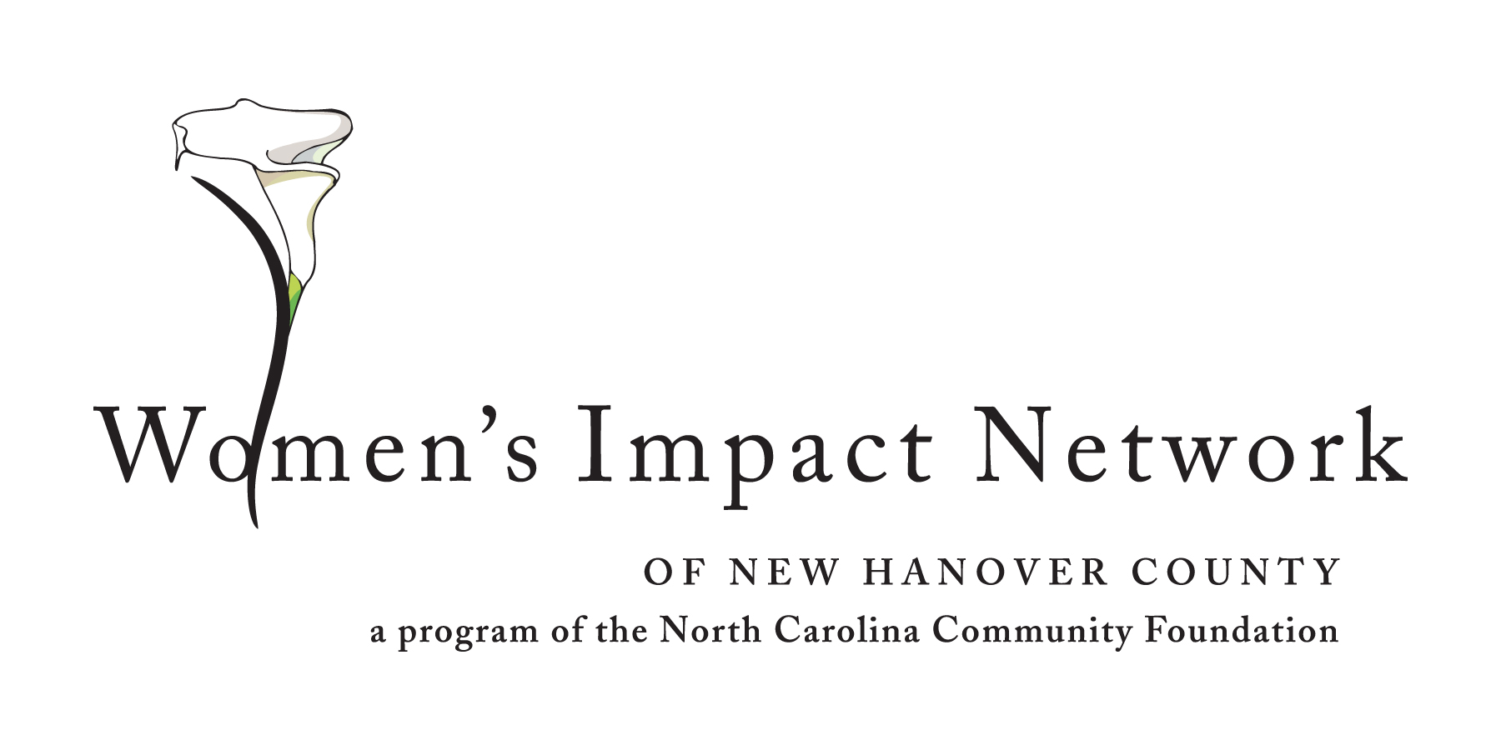
WOMEN’S IMPACT NETWORK OF NEW HANOVER COUNTY
ANNOUNCES FIRST GRANT

FOR IMMEDIATE RELEASE
Sept. 17, 2012

The Women’s Impact Network of New Hanover County will award its first grant to the Cape Fear Guardian ad Litem Association for the “Today’s Child Tomorrow’s Future” initiative at a luncheon on Sept. 20. The $20,000 grant will support educational support services such as tutoring, homework assistance and preparatory standardized testing for foster children in the guardianship of the Department of Social Services.
“We are thrilled to award the Network’s very first grant to such a terrific organization,” said Donis Smith, chair of the Women’s Impact Network. “Our members were so impressed by the dedication of the Guardian ad Litem volunteers. They are with these children every step of the way as they move through the legal system – they give the children a voice in court.”
The Women’s Impact Network, a collective giving program established in 2011 through the New Hanover County Community Foundation, currently has 40 members. Each member’s tax-deductible contribution is deposited into a grant pool administered by the North Carolina Community Foundation, which also provides technical assistance and training to Network members.
“The Women’s Impact Network is like an investment club,” said Jennifer Warren, chair of the Network’s grant committee. “However, instead of researching and buying stocks, we use
- MORE -

Page 2 of 2

a grant application process to evaluate and select a local nonprofit to receive our charitable investment. By pooling our money we can make a much bigger impact on an organization than by writing a single check, and we will be able to really see how our money works.”
The grant awards celebration, which is sponsored by Morgan Stanley Smith Barney, will feature a keynote address by Carla Harris, a managing director in the Institutional Advisory Group at Morgan Stanley Investment Management and remarks by Jennifer Tolle Whiteside, the president and CEO of the North Carolina Community Foundation.
For more information about the Women’s Impact Network of New Hanover County, please contact Patricia Lawler, Regional Associate, North Carolina Community Foundation, at (910) 509-7256 or plawler@nccommunityfoundation.org.
About the North Carolina Community Foundation:
The NCCF is the single statewide community foundation serving North Carolina and has made nearly $68 million in grants since its inception in 1988. With more than $156 million in assets, the NCCF sustains over 1,000 funds and endowments established to provide long-term support of a broad range of community needs, nonprofit organizations, institutions and scholarships. The NCCF partners with 60 affiliate foundations to provide local resource allocation and community assistance in 67 counties across the state. An important component of NCCF’s mission is to ensure that rural philanthropy has a voice at local, regional and national levels. For more information, visit nccommunityfoundation.org and Facebook and follow us on Twitter @NCCF.
# # #
NEWS MEDIA CONTACTS:
Donis Noe Smith
(910) 509-1111, donis.noe.smith@mssb.com

Patricia Lawler, NCCF Regional Associate
(910) 509-7256, plawler@nccommunityfoundation.org

Noel McLaughlin, NCCF Director, Marketing and Communications
919-256-6901; nmclaughlin@nccommunityfoundation.org

