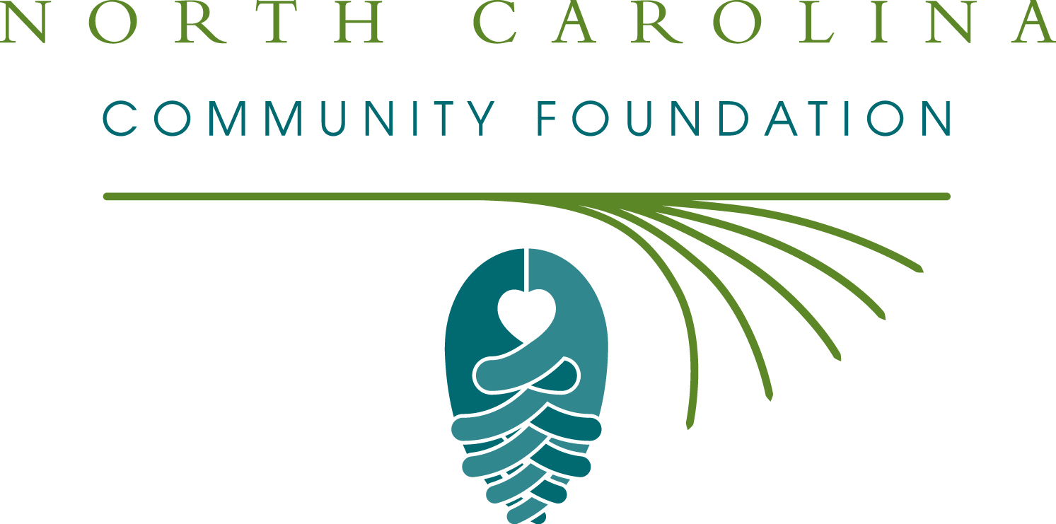

CRAVEN COUNTY COMMUNITY FOUNDATION AWARDS LOCAL GRANTS

September 10, 2012
FOR IMMEDIATE RELEASE

The board of directors of the Craven County Community Foundation announces 2012 awards from its community fund and its component fund, The Richard Chapman Cleve Fund, according to A. Rexford Willis, board president. Grants totaling $86,910 were awarded in a ceremony Monday evening, September 10 at the New Bern Area Chamber of Commerce.
This year’s nonprofit recipients include:
- Carolina East Foundation
- Catholic Charities-Senior Pharmacy Program
- Coastal Carolina Chamber Music Festival
- Coastal Women’s Shelter
- Craven Arts Council and Gallery, Inc.
- Craven County Partners in Education, Inc.
- Craven County Schools – Rachel’s Challenge
- Craven Literacy Council
- Easter Seals-Developmental Day Expansion
- Food Bank of Central & Eastern NC, Inc.
- Merci Clinic
- Monarch “Magical” Garden
- National Society to Prevent Blindness
- NC Extension & Community Association
- Neuse River Foundation, Inc.
- New Millennium Theatre Works, Inc.
- North Carolina Coastal Land Trust
- Religious Community Services of New Bern, Inc.
- Sickle Cell Disease Association – Eastern NC
- Tryon Palace Council of Friends, Inc.
- Vanceboro Christian Help Center
- Vanceboro Farm Life Elementary, “Making Sense of Science”
- Vanceboro United Methodist Church, “Backpack Blessings”
- West Craven High School – “Title Wave”
- West Craven High School – “Setting the Tone”
- West Craven High School –“Project Heart”

Craven County board member and Grants Chair Tyler Harris thanked the community for support of the Craven County Community Foundation. “These grants are important to our community and our quality of life,” he said. “Critical programs would not be possible without the generosity of many individuals and organizations that have supported Craven County’s community fund.” “ We are also thankful for the legacy of generosity left by Mr. Cleve” stated Mr. Harris.
The Craven County Community Foundation is an affiliate of the North Carolina Community Foundation (NCCF). Tax-deductible contributions can be made to the Craven County Community Fund, which is administered by the NCCF. Contributions should be made payable to the Craven County Community Fund and mailed to P.O. Box 3411, New Bern, NC 28564.
For information on the Craven County Community Foundation and its community fund, contact Kim Ball, Regional Associate at 252-670-5929, or visit the NCCF website at nccommunityfoundation.org and click on “Affiliates.”
About the North Carolina Community Foundation:
The NCCF is the single statewide community foundation serving North Carolina and was created 24 years ago to build capacity through philanthropy. The NCCF sustains nearly 1,000 endowment funds established to provide long-term support of a broad range of community needs, nonprofit organizations and scholarships. The NCCF partners with 67 affiliate foundations to provide local resource allocation and community assistance in 65 counties across the state, with an emphasis on rural and underserved areas. For more information, visit nccommunityfoundation.org.
END
NEWS MEDIA CONTACT:

Noel McLaughlin
Director, Marketing and Communications
North Carolina Community Foundation
919-256-6901
nmclaughlin@nccommunityfoundation.org

