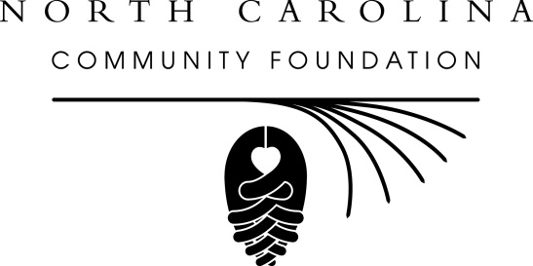

Ellis joins North Carolina Community Foundation’s development team

For immediate release -- Feb. 25, 2014
Megan Lynch Ellis has joined the staff of the North Carolina Community Foundation as a regional development officer, according to Beth Boney Jenkins, NCCF’s vice president for development.
Ellis is responsible for development in the 18 counties that comprise the western and northwestern regions of NCCF’s service area of North Carolina. She works with individuals, businesses and nonprofit organizations to help them create and grow charitable assets to benefit the region. She also works with professional advisors to help them assist their clients with philanthropy. She is based in Boone and also works out of NCCF’s Hickory office.
Prior to joining NCCF, Ellis served as major gifts and special events coordinator for Appalachian Regional Healthcare System. She is the former president of the board of directors of the Children’s Playhouse in Boone and a past treasurer for the Cancer Resource Alliance of the Seby B. Jones Regional Cancer Center.
Ellis attended the University of South Carolina and Temple University, where she graduated magna cum laude with a bachelor’s degree in English. She also earned a certificate in nonprofit management from Duke University. She and her husband live in Boone with their daughter.
MORE

About NCCF
The NCCF is the single statewide community foundation serving North Carolina and has made nearly $74 million in grants since its inception in 1988. With more than $171 million in assets, NCCF sustains 1,200 endowments established to provide long-term support of a broad range of community needs, nonprofit organizations, institutions and scholarships. NCCF partners with 60 affiliate foundations to provide local resource allocation and community assistance in 67 counties across the state. An important component of NCCF’s mission is to ensure that rural philanthropy has a voice at local, regional and national levels. For more information, visit www.nccommunityfoundation.org and Facebook or follow on Twitter@NCCF.
END
News media contact:
Noel McLaughlin, NCCF Director of Marketing and Communications
nmclaughlin@nccommunityfoundation.org
919-256-6901

