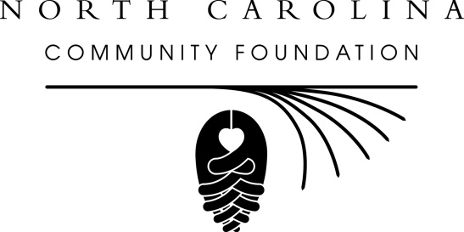
Floyd and Wangerin named to NCCF’s statewide board
For immediate release -- June 22, 2015
The North Carolina Community Foundation (NCCF) is pleased to announce the appointment of two new directors to the statewide board, according to Linda Staunch, chair.
Named were Alexander Graham Floyd and Steven Wangerin. As members of the board, these statewide directors will provide leadership in the areas of funds development, grantmaking and strategic planning to ensure that the organization continues to meet community needs across North Carolina. Board members also serve as the Foundation’s ambassadors throughout the state.
Floyd lives in Granville County and Raleigh. He is founder and president of Floyd Oil Company. The privately held, family owned company focuses on the acquisition of long life oil and gas assets in the southwestern United States as well as real estate and venture capital in North Carolina. He is a graduate of UNC-Chapel Hill, where he received both his undergraduate and graduate degrees. He was educated at Virginia Episcopal School, where he is a former trustee and remains active as a volunteer. He attends Christ Episcopal Church in Raleigh.
Wangerin is CEO of W.T. Humphrey, Inc. in Jacksonville, which is the parent company for several enterprises that provide general and mechanical contracting for federal projects in the southeastern United States. He is a graduate of UNC-Charlotte and the Louisiana State University Graduate School of Banking. Wangerin is involved in many organizations and civic activities, including the NC Infrastructure Authority; the Jacksonville Rotary Club; the Jacksonville-Onslow Economic Development Board, which he chairs; and serving as president of the Onslow Caring Communities Foundation, an affiliate of NCCF.
NCCF’s CEO and President Jennifer Tolle Whiteside said she was looking forward to working with the new board members. “Both Alex and Steve bring a wealth of business acumen to our board and a deep knowledge of our North Carolina communities,” she said. “They will be true assets to our statewide board.”
About the North Carolina Community Foundation
The NCCF is the single statewide community foundation serving North Carolina and has made nearly $89 million in grants since its inception in 1988. With more than $191 million in assets, NCCF sustains 1,200 endowments established to provide long-term support of a broad range of community needs, nonprofit organizations, institutions and scholarships. The NCCF partners with 60 affiliate foundations to provide local resource allocation and community assistance in 67 counties across the state. An important component of NCCF’s mission is to ensure that rural philanthropy has a voice at local, regional and national levels.
For more information, visit nccommunityfoundation.org and Facebook or follow on LinkedIn and Twitter @NCCF.
END
NEWS MEDIA CONTACT:
Noel McLaughlin, NCCF Director of Marketing & Communications
919-256-6901
nmclaughlin@nccommunityfoundation.org

